**2020 Kenai Beach Bacteria Monitoring Report**

FY20-21 Final Report

**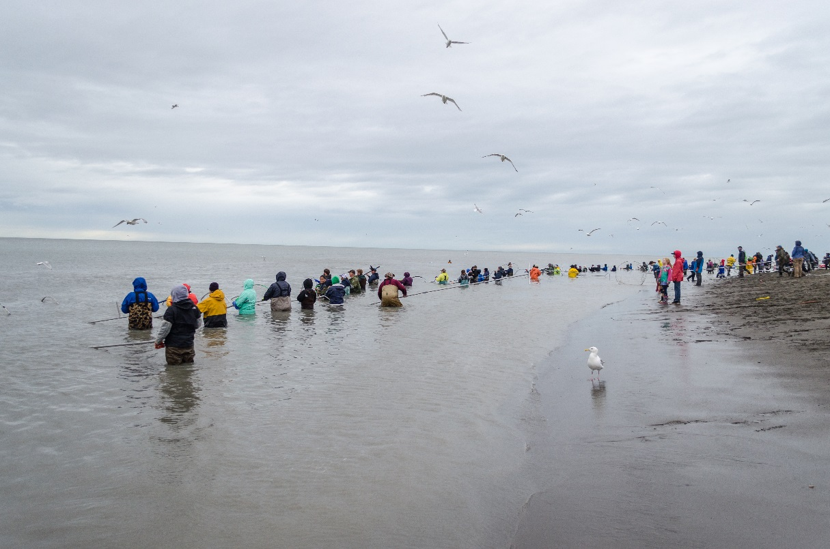**

Prepared for the Alaska Department of Environmental Conservation

Grant: ACWA-19-B11

***The Kenai Watershed Forum is dedicated to successfully identifying and addressing the needs of the region by providing high quality education, restoration, and research programs.***

******

***“Working together for healthy watersheds on the Kenai Peninsula”***

**Draft report: February 25, 2021**

**Prepared by:**

Benjamin Meyer

Environmental Scientist

44129 Sterling Highway

Soldotna, Alaska 99669

(907) 260-5449

[www.kenaiwatershed.org](http://www.kenaiwatershed.org)

*This project has been funded wholly or in part by the United States EPA under assistance agreement number (BEACH-CU-00J71801) to the Department of Environmental Conservation through the Alaska Clean Water Actions (ACWA) program. The contents of this document do not necessarily reflect the views and policies of the EPA, nor does the EPA endorse trade names or recommend the use of commercial product mentioned in this document.*

Table of Contents

[**List of Tables iv**](#_Toc64228856)

[**List of Figures iv**](#_Toc64228857)

[**Acronyms iv**](#_Toc64228858)

[**Executive summary 1**](#_Toc64228859)

[**Introduction 2**](#_Toc64228860)

[**Methods 4**](#_Toc64228861)

[**Monitoring locations 4**](#_Toc64228862)

[**Sampling design 7**](#_Toc64228863)

[**2019-2020: Microbial source tracking 7**](#_Toc64228864)

[**Quality assurance and quality control 8**](#_Toc64228865)

[**Water quality standards. 8**](#_Toc64228866)

[**Public outreach 10**](#_Toc64228867)

[**Results 10**](#_Toc64228868)

[**Bacteria concentrations monitoring 2019 – 2020 10**](#_Toc64228869)

[**Water quality standards analysis 12**](#_Toc64228870)

[**Fecal Coliform 14**](#_Toc64228871)

[**Enterococci 17**](#_Toc64228872)

[**2019 - 2020 Microbial Source Tracking Data 19**](#_Toc64228873)

[**Discussion 20**](#_Toc64228874)

[**2020 Kenai beach bacteria monitoring 20**](#_Toc64228875)

[**2019-2020 Microbial source tracking (MST) 23**](#_Toc64228876)

[**Conclusions and recommendations 24**](#_Toc64228877)

[**Data availability 25**](#_Toc64228878)

[**References 26**](#_Toc64228879)

[**Appendix A: Site Photographs 29**](#_Toc64228881)

[**Appendix B: Press Releases (Page 1 of 5) 34**](#_Toc64228882)

[**Appendix C: Chain-of-Custody 39**](#_Toc64228883)

[**Appendix D: Marine Beach Sanitary Survey 40**](#_Toc64228884)

[**Appendix E: 2020 Samples Values and Exceedances 41**](#_Toc64228885)

[**Appendix F: Microbial Source Tracing Data 47**](#_Toc64228886)

[**Appendix G: ADEC Water Quality Standards 48**](#_Toc64228887)

# **List of Tables**

[Table 1 – 2019-2020 Kenai beach bacteria monitoring sites. 5](#_Toc64229317)

[Table 2 – Summary statistics by site and bacteria species. 12](#_Toc64229318)

[Table 3 – Mean percent difference between replicate sample values 12](#_Toc64229319)

[Table 4 – Overall seasonal criteria exceedances for fecal coliform and enterococci. 14](#_Toc64229320)

[Table 5 – Percent of fecal coliform samples exceeding seasonal criteria. 16](#_Toc64229321)

[Table 6 – Seasonal geometric mean values. 17](#_Toc64229322)

[Table 7 – Percent of enterococci samples exceeding seasonal criteria. 19](#_Toc64229323)

[Table 8 – Microbial source tracing data 2019 – 2020 47](#_Toc64229324)

# **List of Figures**

[Figure 1 – Kenai River and Kenai Beach dipnet personal use areas 2](#_Toc64229495)

[Figure 2 – Kenai River beach sampling sites and general gull rookery area. 6](#_Toc64229496)

[Figure 3 – Bacteria sample concentration values from 2019 and 2020. 11](#_Toc64229497)

[Figure 4 – Timing of fecal coliform and enterococci sample exceedances. 13](#_Toc64229498)

[Figure 5 – Fecal coliform sample valuesby site 15](#_Toc64229499)

[Figure 6 – Thirty day geometric mean fecal coliform values 16](#_Toc64229500)

[Figure 7 – Enterococci sample values by site. 18](#_Toc64229501)

[Figure 8 – Thirty day geometric mean enterococci values. 18](#_Toc64229502)

[Figure 9 – Microbial source tracing (MST) data by site and species. 19](#_Toc64229503)

[Figure 10 – Growth of the Kenai River personal use fishery 21](#_Toc64229504)

[Figure 11 – 2017 – 2020 late run sockeye salmon counts on the Kenai River. 22](#_Toc64229505)

# **Acronyms**

**ADEC** – Alaska Department of Environmental Conservation

**ADF&G** – Alaska Department of Fish and Game

**BEACH** – Beaches Environmental Assessment and Coastal Health Act

**BEACON** – Beach Advisory and Closing Online Notification system

**BMP** – Best Management Practices

**CFU** – Colony Forming Unit

**CoK** – City of Kenai

**EPA** – Environmental Protection Agency

**KWF** – Kenai Watershed Forum

**MST** – Microbial Source Tracking

**PUF** – Personal Use Fishery

**U.S. FWS** – United States Fish and Wildlife Service

# **Executive summary**

Under contracts with the City of Kenai, the Kenai Watershed Forum has worked with the Alaska Department of Environmental Conservation’s Alaska Beach Program since 2010 to monitor bacteria concentrations at public recreational beaches at the outlet of the Kenai River in Kenai, Alaska. Bacteria monitored included fecal coliform and enterococci, both of which are found in the excrement of warm-blooded animals such as gulls, which are attracted to Kenai beaches by fish carcasses produced during the personal use dipnet fishery. To establish a baseline for bacteria concentrations, and inform the public when criteria are exceeded, Kenai Watershed Forum began monitoring pathogens from 2010-2014 at selected sites. In 2015, best management practices were implemented by the City of Kenai, which included clearing fish carcasses from the beaches at night during the personal use fishery to reduce attractants to gulls. To assess changes in bacteria concentrations post-implementation of best management practices, Kenai Watershed Forum conducted monitoring from 2018-2020 at sites located at the North and South Kenai Beaches; Warren Ames Memorial Bridge; and upstream and downstream of the gull rookery. Microbial source tracking was conducted prior to and during the in order to identify sources of these bacteria in 2019 and 2020.

In the 2020 monitoring season, data indicated instances of fecal coliform concentrations above advisory level for harvest of seafood for raw consumption at all sample sites, as well as some instances of enterococci concentrations above advisory level for contact recreation at South Kenai Beach. The report makes recommendations for the continuation of successful beach monitoring efforts in conjunction with the use of the Environmental Protection Agency’s Virtual Beach Model.

# **Introduction**

The Kenai River is a glacially-fed river located on Alaska’s Kenai Peninsula that begins at the outlet of Kenai Lake and flows into Cook Inlet, a branch of the Gulf of Alaska. Known internationally for its prolific fisheries, the Kenai River supports the Cook Inlet’s largest population of wild Pacific Salmon. Each summer, thousands of recreationists participate in the Kenai River sport fishing season, which includes an Alaska resident-only personal use fishery (PUF) during much of July.

Since 1996, the Alaska Department of Fish and Game (ADFG) has managed the dipnet PUF for Alaska residents under the Kenai River Late-Run Sockeye Salmon Management Plan (5 AAC 21.350, 2020). The PUF is generally open from July 10th to July 31st starting from the Warren Ames Memorial Bridge between miles five and six of the Kenai River, to the mouth of the river, where the boundary extends along the North and South Kenai Beaches (Figure 1). While providing ample fishing and recreational opportunities for state resident recreationists, the PUF also bolsters the local economy and is highly valued by many throughout the state. However, the fishery annually results in accumulation of fish carcass waste along the North and South Kenai beaches from fish cleaned on site by users.

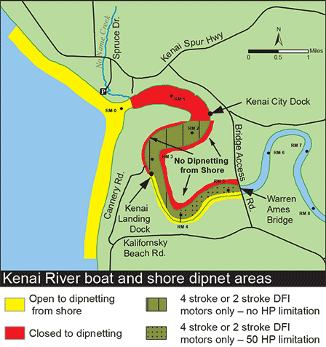

Figure 1 - Kenai River and Kenai Beach dipnet personal use

fishery access locations (Alaska Department of Fish and Game, 2018).

Common practice of recreationists within the dipnet PUF involves processing fish and discarding the waste along the beaches or within nearshore ocean water. It is also common to store freshly caught fish on the beaches before processing them. The fish and resulting waste exposed along the beaches draws thousands of gulls from an established upstream gull rookery to the area each day to feed. The excrement from these gulls carries bacteria including fecal coliform bacteria and enterococci, which affect water quality along the North and South Kenai Beaches. When in exceedance of State of Alaska Water Quality Standards (18 AAC 70), these bacteria can be indicative of water containing concentrations of other bacteria that could induce human illness.

Monitoring for fecal coliform and enterococci bacteria was initiated in 2010 as part of the Alaska Beach Monitoring Program, part of the Environmental Protection Agency’s (EPA) BEACH Program, a national effort to decrease the incidence of water-borne illnesses at public beaches under the federal Beaches Environmental Assessment and Coastal Health Act (BEACH). Throughout the 2010-2014 monitoring seasons, bacteria concentrations were found to periodically exceed the state standards throughout this timeframe. In response, the City of Kenai (CoK) developed best management practices (BMPs) in 2014, and implemented them during the 2015 recreational season. These BMPs included nightly clearing of fish carcasses from North and South Kenai Beaches and installing portable toilets during the PUF season. Such practices were executed with the goal of reducing sources of bacteria, thereby minimizing the exposure of recreationists and fishermen. Bacteria monitoring was paused during this period to allow for the implementation of BMPs.

Starting in 2018, Kenai Watershed Forum (KWF), contracted through the CoK, worked with ADEC to sample for fecal coliform bacteria and enterococci concentrations. The sampling objective was to monitor changes in these bacteria concentrations post-BMP implementation. Weekly bacteria sampling was conducted from May-September 2019 and 2020 at the North and South Kenai Beaches, two sites near the upriver gull rookery, and near the Warren Ames Memorial Bridge (Figure 2).

Potential sources of terrestrial feces (gull, human, and dog) were examined using microbial source tracking (MST) (Green et al., 2019), a method used to identify sources of fecal contamination based on species-specific genetic markers (e.g. DNA) present in samples. MST analysis is able to detect trace amounts of DNA in a sample, and in this study was used to quantify the proportional contribution from each animal species to fecal matter concentrations. MST analyses were conducted in 2019 and 2020 before and during the PUF.

Water quality exceedances of both fecal coliform and enterococci were identified throughout the 2018-2020 recreational seasons, particularly at the North and South Kenai Beach sampling locations. In response, KWF collaborated with the CoK and ADEC to conduct public outreach and education centered on preventative measures the public could take in order to avoid contact with contaminated water.

This report focuses on the 2020 monitoring season. Some results from the 2019 are included for comparison. A complete analysis of the 2019 and 2018 field seasons are included in a previously published report (Harings, 2020).

# **Methods**

Prior to monitoring each sampling season, the Alaska Department of Environmental Conservation’s (ADEC) BEACH Water Quality Monitoring and Pathogen Detection Quality Assurance Project Plan (QAPP) was revised for sampling at five predetermined sites within the lower reaches of the Kenai River as well as along the North and South Kenai Beaches. Kenai Watershed Forum (KWF) personnel were trained in sampling techniques using the methods outlined in the QAPP and sampling was supervised by senior personnel throughout the summer for consistency and technique. ADEC also joined for one sampling event each season for quality assurance.

## **Monitoring locations**

All five monitoring locations (Table 1 and Figure 2) are located within the lower six miles of the Kenai River. During peak recreation and fishing periods in July and August, this area experiences high pressure from both commercial and personal-use power boats as well as bank fisherman during the dipnet personal use fishery (PUF) from July 10th - July 31st. The most upstream site, Warren Ames Memorial Bridge, receives little pressure from fishermen and was chosen as a monitoring site for background pathogen concentrations. Further downstream near the Kenai River outlet is a large gull rookery located on river left that plays host to thousands of gulls in summer. The North and South Kenai Beaches located near the Kenai River outlet draws twenty to thirty thousand dipnetters annually during the personal use fishery season (ADFG, 2021). Sampling site photographs can be found in Appendix A: Site Photographs.

Table 1 - 2019-2020 Kenai beach bacteria monitoring site locations and descriptions.



**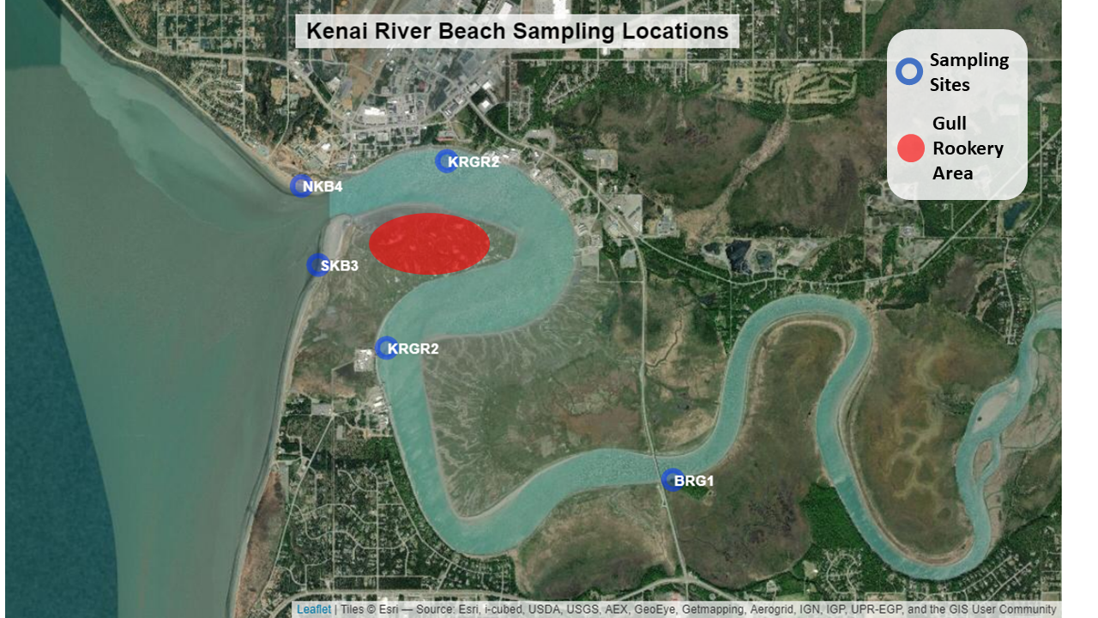**

Figure 2. 2019-2020 Kenai River beach sampling sites and general gull rookery area. See Figure 1 for personal use fishery beach areas.

## **Sampling design**

Sites selected for monitoring throughout the 2019 and 2020 sampling seasons remained consistent with those used in previous year and consisted of the Warren Ames Memorial Bridge (BRG1), above and below the gull rookery in the Kenai River (KRGR1 and KRGR2, respectively), and two different areas on both the North (NKB4) and South (SKB3) Kenai Beaches (Figure 2).

During sampling events, site visits were conducted within a few hours of high tide, as it was necessary to time boat launch and retrieval at the City of Kenai docks with high water conditions. Sites near the gull rookery were accessed by boat while all other sites were accessed by foot. At each site, two 100-mL grab samples of water were collected from the river: one for fecal coliform bacteria and one for enterococci. A set of replicate samples was collected for quality control during each sampling event, rotating between the North and South Kenai Beach sampling sites. In-situ air and water temperatures were collected using an YSI 650 MDS or YSI Pro 20 multiprobe meter; local observations were made regarding the weather, tides, beach, activity noted on the beach, and potential sources of contamination (gulls, boats, etc.). Wave height and turbidity were also assessed in 2020 at the Warren Ames Memorial Bridge and both North and South Kenai Beaches using a yard stick and Hach 2100Q Portable Turbidimeter, respectively. For the purpose of quantifying and referencing observed fishermen, campers, and other beachgoers, the all-encompassing term “recreationists” will be used throughout this report. All field observations were recorded on an EPA Marine Beach Sanitary Survey found in Appendix D: Marine Beach Sanitary Survey.

All grab samples were packaged and shipped on ice with a chain-of-custody form (see Appendix C: Chain-of-Custody) within six hours of sampling via commercial air carrier to ADEC-certified laboratory, SGS North America Inc., for analyses in Anchorage. As required by the project QAPP, the quantity of fecal coliform bacteria per 100-mL sample was determined using analytical method ID SM-9222D while the quantity of enterococci per 100-mL sample was determined using analytical method ID D6503-99 (ADEC: Division of Water, 2012). Results of these analyses were reported by the laboratory to KWF and ADEC within 48 hours of receiving the samples. If exceedances were present, ADEC would issue a notice of exceedance to stakeholders (Appendix B: Press Releases). Ongoing outreach efforts by CoK and KWF included sign postings, and an on-site public information booth during the PUF.

### 2019-2020: Microbial source tracking

Sampling for MST was conducted at all five Kenai River bacteria monitoring locations in 2019 and 2020. MST methodology was employed to test for the presence of dog, human, and gull fecal matter- all of which are potential sources contributing to bacteria concentrations in the Kenai River system. In 2019, the first sampling event occurred prior to start of the PUF on June 4th and on August 1st, 2019. In 2020, MST sampling events took place on June 23rd and July 20th.

All sampling events for MST corresponded with a standard bacteria sampling event. Prior to each sampling event, five 500-mL sterile sampling bottles were packaged individually wrapped in paper towels and stored in zip lock bags. Once in the field, personnel cleaned hands and wore new disposable gloves. Sample bottles remained closed until immediately prior to sample collection. Each bottle was labeled with sampling location, sample type (MST), date, and time. One grab sample was taken per monitoring location and subsequently packaged and shipped on ice with a corresponding chain-of-custody form (Appendix C: Chain-of-Custody) within six hours of sampling via commercial air carrier to the ADEC-certified laboratory, SGS North America Inc. (SGS), in Anchorage. To concentrate bacteria within the samples, SGS processed all samples via a sterile, vacuum filtration method. All resulting filters were stored in a freezer until notified by KWF to overnight mail the frozen samples with a temperature blank to ADEC-approved Source Molecular in Miami, Florida, where the bacteria source was identified by genetic markers using quantitative polymerase chain reaction (qPCR) and Digital PCR technologies.

## **Quality assurance and quality control**

Monitoring methods and data were reviewed for quality control and assurance by the ADEC Project Manager as well as the KWF Project Quality Assurance Officer.

Quality control samples were taken for both fecal coliform and enterococci analyses. These samples alternated between the North and South Kenai Beaches each week. When duplicate sample values existed, only the higher of the two values were used in data summary and analyses presented in this report. Using only the higher of two replicate is a more conservative approach that is appropriate in this application because data pertains to public health and safety.

All data was uploaded to the state Ambient Water Quality Monitoring System (AQWMS) by ADEC, and later to the national EPA Beach Data repository (EPA, 2021a), publicly accessible using the online Beach Advisory Closing Online Notification (BEACON) tool (EPA, 2021b).

## **Water quality standards**.

Fecal coliform and enterococci analyses results from the 2020 monitoring seasons were evaluated based on the Alaska Water Quality Standards for marine water (18 AAC 70 (14)) (Appendix G). Results were evaluated against in-season management criteria, as well as post-season retrospective criteria. When two sub-criteria are specified (i.e., geometric mean and 10% of samples in a season), both criteria must both be met or the site fails the standard.

When in-season geometric mean values are calculated, a minimum of five samples spaced over thirty days were used.

Results were evaluated in the context of (18 AAC 70 (14)) water quality standards as follows:

*Fecal coliform*

Fecal coliform exceedances were determined based on standards set for:

1. Secondary water recreation (18 AAC 70 (14)(B)(ii))
   1. In-season exceedances for secondary contact recreation were identified when
      1. Individual fecal coliform sample values exceeded 400 CFU/100 mL, or
      2. The geometric mean of fecal coliform samples exceeded 200 CFU/100 mL over a 30 day period.
   2. Post-season site exceedances were identified if 10% of fecal coliform sample values from the entire season exceeded 400 CFU/100 mL.
2. Harvesting raw aquatic life for consumption (18 AAC 70 (14)(D))
   1. In-season exceedances for harvesting raw aquatic life for consumption were identified when
      1. Individual fecal coliform samples exceeded 31 CFU/100 mL
   2. Post-season site exceedances were identified when
      1. 10% of fecal coliform samples from season exceeded 31 CFU/100 mL, or
      2. The geometric mean of fecal coliform samples from the season exceeded 14 CFU/100 mL.

*Enterococci*

Enterococci exceedances were determined based on standards set for:

1. Contact recreation (18 AAC 70 (14)(B)(i))
   1. In-season exceedances for contact recreation were identified when
      1. Individual enterococci samples exceeded 130 CFU/100 mL
      2. The geometric mean of enterococci samples exceeded 35 CFU/100 mL over a 30 day period.
   2. Post-season site exceedances were identified when 10% of enterococci samples exceeded 130 CFU/ 100 mL

The above standards as described in Alaska Water Quality Standards for Marine Water (18 AAC 70 (14)) appear in Appendix G.

ADEC issued a general [public notice](https://dec.alaska.gov/commish/press-releases/20-04-2020-recreational-beach-monitoring-for-kenai-beaches/" \t "_blank) at the start of the 2020 recreation season, posted weekly updates/advisories on the ADEC Facebook page, and emailed the weekly results to an email listserv of community stakeholders. When an exceedance for harvesting raw aquatic life for consumption occurred, ADEC seafood monitoring personnel were notified along with other stakeholders through the Alaska Beach Program email listserv.

## **Public outreach**

Public outreach remained a critical component of effective bacteria monitoring during the 2019 and 2020 monitoring seasons. ADEC and the CoK partnered with Stream Watch, a KWF and U.S. Forest Service program specializing in angler education and outreach, to disseminate information on ways to avoid contact with bacteria and proper fish handling at North Kenai Beach. Education was provided in the form of brochures and personal communication. Booth visitors verbally expressed their appreciation for handouts including fin clippers and dog bags, which aim to help reduce the fecal bacteria contributed by dogs along the beach. Volunteer participation metrics were recorded in 2020 and include staffing a booth for 59 hours during which volunteers conducted peer-to-peer education with 383 recreationists, as well as a total of 93 pounds of trash collected.

In 2019 and 2020, ADEC issued educational radio ads that were played four times per week during the PUF. In addition, weekly water quality status updates were posted to the [ADEC Facebook page](https://www.facebook.com/AlaskaDEC/) (Appendix B).

The [ADEC Beach Webpage](https://dec.alaska.gov/water/water-quality/beach-program/kenai-river-beaches-dipnetting-safety) was updated to include interactive maps, and provided information on beach monitoring and guidelines for minimizing contact with bacteria. In 2019 stakeholders were emailed weekly updates on Kenai Beach monitoring. In 2020, a beach notification listserv was developed to replace the previous notification system.

# **Results**

## **Bacteria concentrations monitoring 2019 – 2020**

A total of 161 enterococci samples and 162 fecal coliform sample concentrations, including replicates, are present in the 2019-2020 data set. Figure 3 presents the range of sample concentration values from both years for comparison.

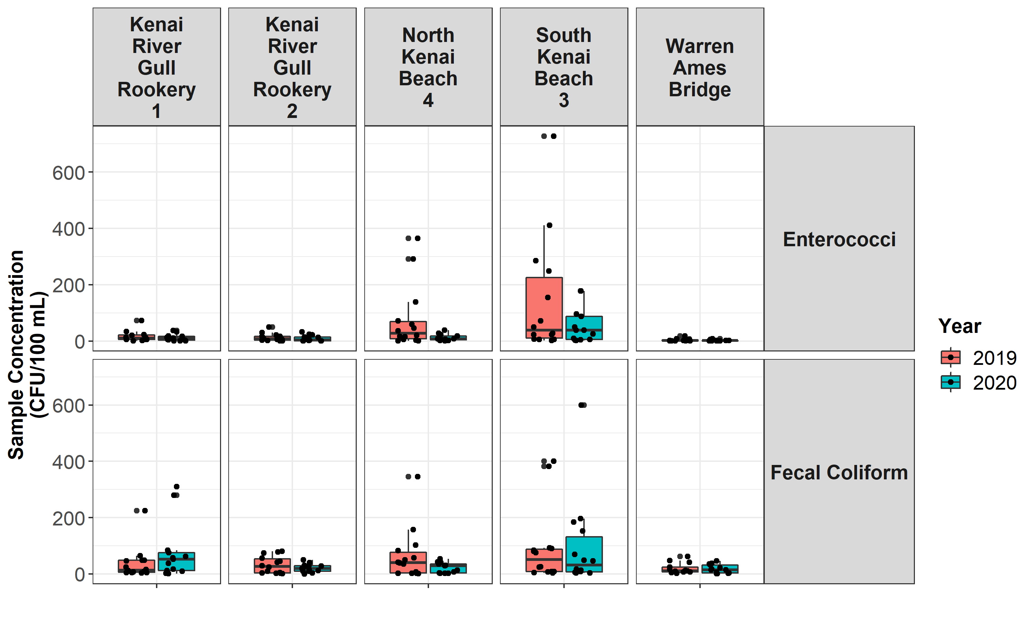

Figure 3 – Bacteria sample concentration values from 2019 and 2020.

Figure 3 indicates that sample concentrations occupied roughly similar ranges in both 2019 and 2020 at most sites. Notably, at North Kenai Beach and South Kenai Beach, enterococci concentrations occupied a higher range of values in 2019 relative to 2020.

Table 2 presents summary statistics (mean ± standard error, minimum, and maximum) from the 2020 sampling season for both individual sample values and thirty-day geometric mean sample values.

Fecal coliform individual sample values overall in 2020 ranged 1 – 600 CFU/100 mL, and were highest on average at the South Kenai Beach site (147.16 ± 71.09 CFU/100 mL, mean ± std. error). Thirty-day geometric mean fecal coliform values overall in 2020 ranged 1.00 – 94.87 and were highest on average at the Kenai River Gull Rookery 1 site (61.09 ± 41.62 CFU/100 mL, mean ± std. error).

Enterococci individual sample values overall in 2020 ranged 0.5 – 178 CFU/100 mL, and were highest on average at South Kenai Beach site (74.12 ± 25.96 CFU/100 mL, mean ± std. error). Thirty-day geometric mean enterococci values were also highest on average at South Kenai Beach (29.09 ± 25.96 CFU/100 mL, mean ± std. error).

Variation between 2020 replicate samples averaged 40.58 ± 7.03 % (mean ± std. error) for enterococci and 24.12 ± 4.40 % (mean ± std. error) for fecal coliform samples (Table 3).

For complete 2020 data applied in determining threshold criteria exceedance see Appendix E: 2020 Samples Values and **Exceedances (Page** . Raw analytical results can also be found at the [ADEC BEACH program Kenai River page](https://dec.alaska.gov/water/water-quality/beach-program/kenai-river/), and from 2010 – present in the [EPA BEACON data base](https://watersgeo.epa.gov/beacon2/).

Table 2 - Summary statistics by site and bacteria species for the 2020 sampling season; individual sample concentrations and thirty-day geometric mean values. All sample result values are in CFU/100 mL.

|  |  |  |  |  |  |  |  |
| --- | --- | --- | --- | --- | --- | --- | --- |
| **Bacteria** | **Location** | **Individual Sample Mean ± Std. Error** | **Individual Sample Min** | **Individual Sample Max** | **30 Day Geometric Mean Value Mean ± Std. Error** | **30 Day Geometric Mean Value Min** | **30 Day Geometric Mean Value Max** |
| Enterococci | Kenai River Gull Rookery 1 | 15.19 ± 4.79 | 0.50 | 37.00 | 7.84 ± 4.79 | 4.02 | 10.37 |
| Enterococci | Kenai River Gull Rookery 2 | 11.62 ± 4.52 | 0.50 | 33.00 | 4.52 ± 4.52 | 2.83 | 8.24 |
| Enterococci | North Kenai Beach 4 | 10.81 ± 4.6 | 0.50 | 38.00 | 6.05 ± 4.6 | 2.61 | 10.02 |
| Enterococci | South Kenai Beach 3 | 74.12 ± 25.96 | 3.00 | 178.00 | 29.09 ± 25.96 | 14.54 | 39.75 |
| Enterococci | Warren Ames Bridge | 2.25 ± 0.88 | 0.50 | 8.00 | 1.48 ± 0.88 | 1.00 | 1.89 |
| Fecal Coliform | Kenai River Gull Rookery 1 | 109.88 ± 41.62 | 3.00 | 310.00 | 61.09 ± 41.62 | 33.52 | 94.87 |
| Fecal Coliform | Kenai River Gull Rookery 2 | 24.16 ± 5.5 | 3.30 | 50.00 | 18.9 ± 5.5 | 12.62 | 24.43 |
| Fecal Coliform | North Kenai Beach 4 | 23.02 ± 6.21 | 2.00 | 43.00 | 12.84 ± 6.21 | 7.03 | 20.33 |
| Fecal Coliform | South Kenai Beach 3 | 147.16 ± 71.09 | 5.70 | 600.00 | 47.01 ± 71.09 | 13.05 | 79.44 |
| Fecal Coliform | Warren Ames Bridge | 16.46 ± 5.99 | 1.00 | 46.00 | 11.22 ± 5.99 | 6.01 | 15.92 |

Table 3 - Mean percent difference between replicate sample values, all 2020 replicate samples.

|  |  |  |
| --- | --- | --- |
| **Bacteria** | **Replicate Samples** | **% Difference Between Replicates (Mean ± Standard error)** |
| Enterococci | 26 | 40.58 ± 7.03 % |
| Fecal Coliform | 26 | 24.12 ± 4.40 % |

## **Water quality standards analysis**

Bacteria monitoring efforts in 2020 revealed some instances of exceedance for both in-season and post-season criteria based on the Alaska Water Quality Standards. Timing of in-season criteria exceedances are summarized for all standards in Figure 4 and overall seasonal criteria exceedances are summarized by site in Table 4.

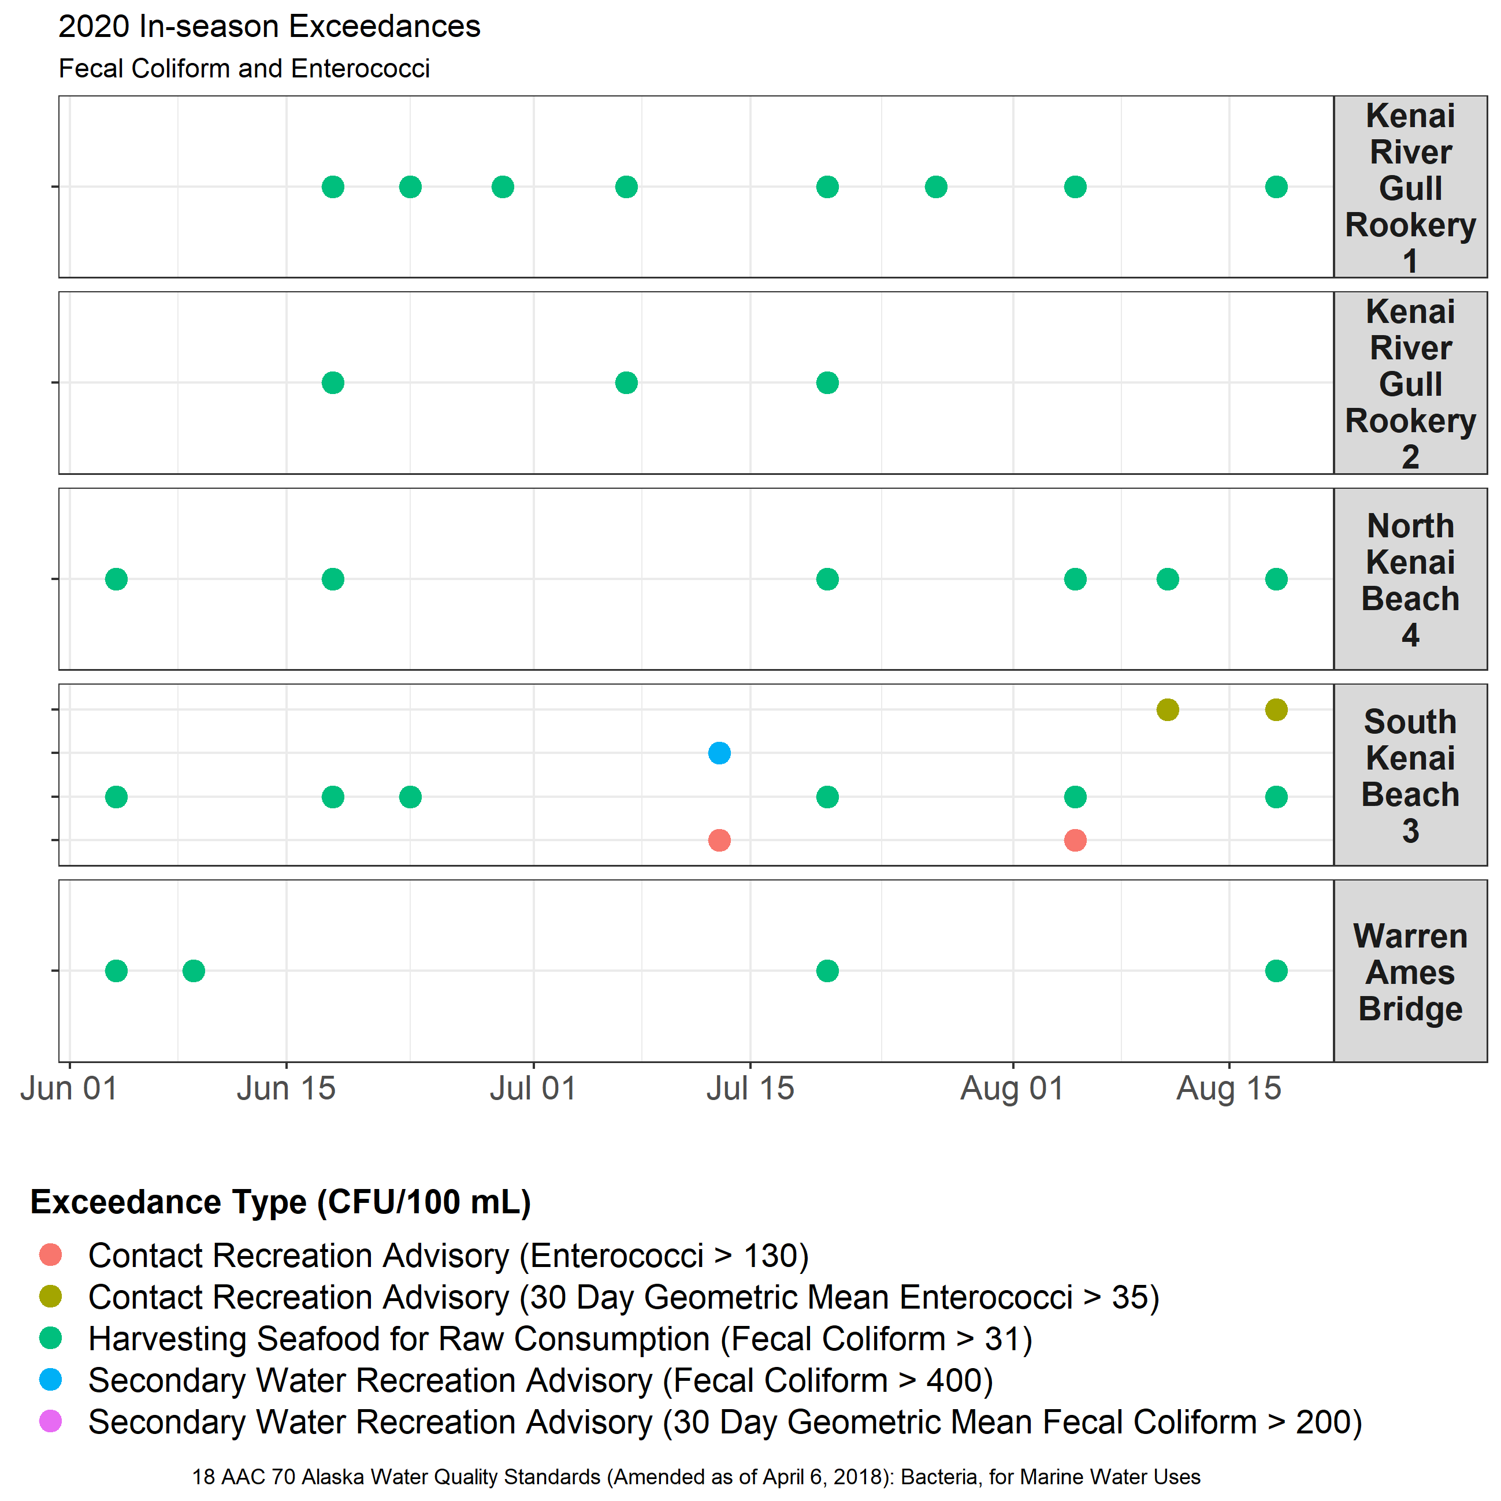

Figure 4 – Timing of fecal coliform and enterococci sample exceedances in 2020 of criteria described in 18 AAC 70 Alaska Water Quality Standards.

Table 4 - Overall seasonal criteria exceedances for fecal coliform and enterococci by site for the 2020 sampling season.



The following sections describe fecal coliform and enterococci sample values from the 2020 sampling season in greater detail, in context of 18 AAC 70 regulations.

## **Fecal Coliform**

Fecal coliform sample values from 2020 are interpreted in context of 18 AAC 70 Alaska Water Quality Standards as follows:

*Secondary Water Recreation*

* + - In-season criteria (Figure 5)
      * One individual fecal coliform sample of > 400 CFU/100 mL was observed at one site (South Kenai Beach) on one date.
      * Thirty-day geometric mean fecal coliform values of >200 CFU/100 mL were not observed at any sites.
    - Post-season criteria (Table 5)
      * At no sites were 10% of all fecal coliform samples from the season > 400 CFU/100.

*Harvesting Raw Aquatic Life for Consumption*

* + - In-season criteria (Figure 5)
      * At all five sites, on various dates, individual fecal coliform samples exceeding 31 CFU/100 mL were observed.
    - Post-season criteria
      * At all five sites 10% of all fecal coliform samples from a season exceeded 31 CFU/100 mL (Table 5).
      * The overall seasonal geometric mean of fecal coliform samples exceeded 14 CFU/100 mL at two sites (South Kenai Beach, and Kenai River Gull Rookery 1) (Table 6)).

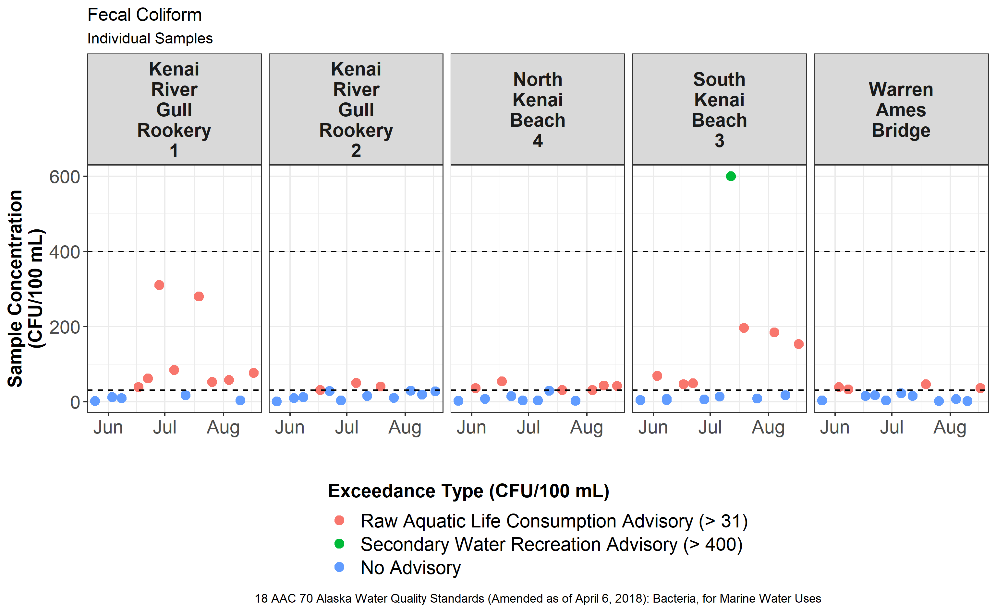

Figure 5 – Fecal coliform concentrations from lower Kenai River sites in 2020, color coded by exceedance standard criteria. Dotted lines indicate criteria thresholds for individual samples of 31 CFU/100 mL and 400 CFU/100 mL.

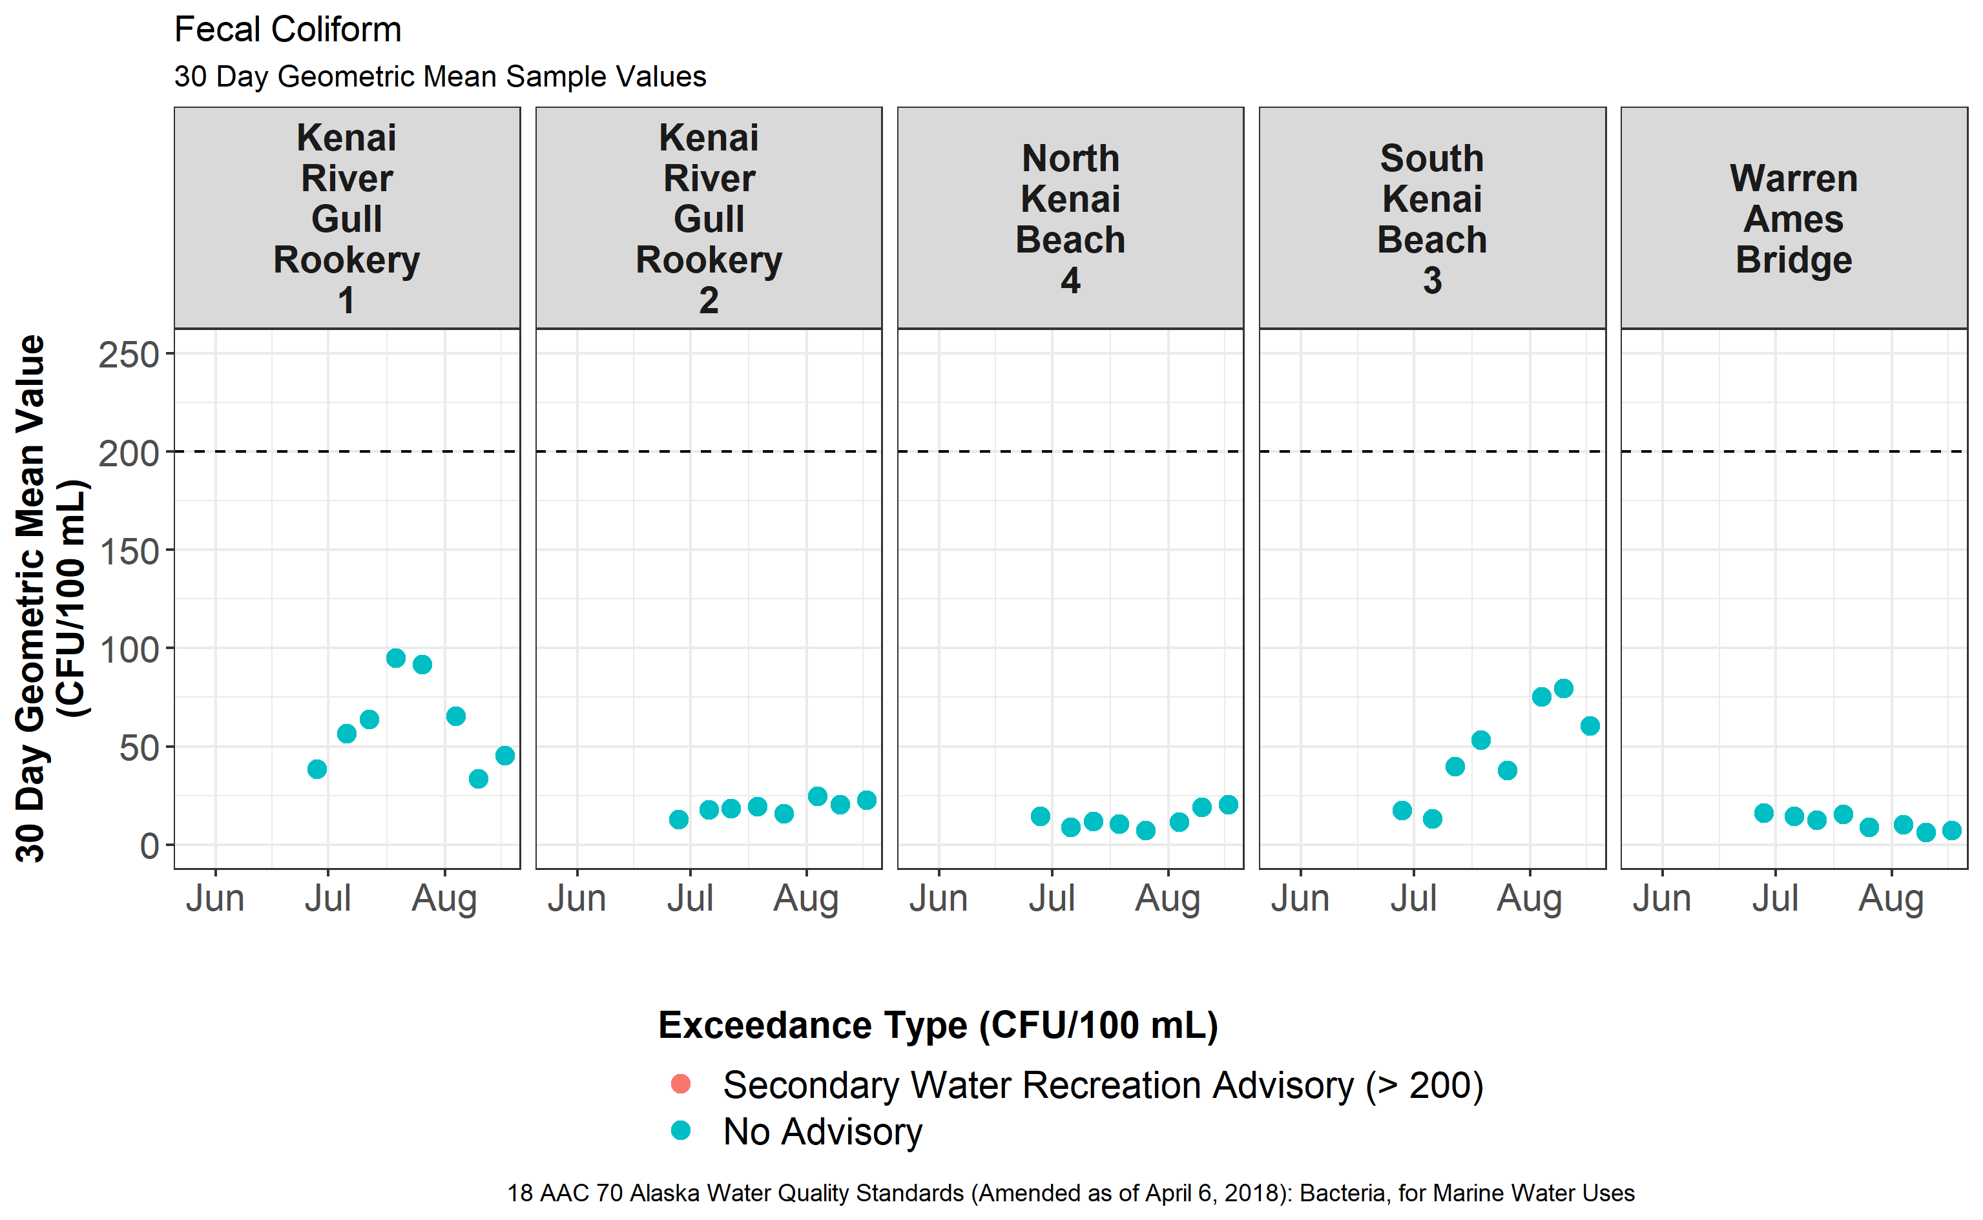

Figure 6 – Thirty day geometric mean values of fecal coliform samples from lower Kenai River sites in 2020, color coded by exceedance standard criteria. Dotted line indicates criteria threshold for geometric mean sample values.

Table 5 – Percent of fecal coliform samples from the 2020 sampling season that exceeded a specified criteria standard.

|  |  |  |  |
| --- | --- | --- | --- |
| **Location** | **Standard (CFU/100 mL)** | **% of Fecal Coliform Samples Above Standard** | **Pass/Fail** |
| Kenai River Gull Rookery 1 | 31 | 61.5% | fail |
| Kenai River Gull Rookery 2 | 31 | 23.1% | fail |
| North Kenai Beach 4 | 31 | 46.2% | fail |
| South Kenai Beach 3 | 31 | 42.9% | fail |
| Warren Ames Bridge | 31 | 30.8% | fail |
| Kenai River Gull Rookery 1 | 400 | 0.0% | pass |
| Kenai River Gull Rookery 2 | 400 | 0.0% | pass |
| North Kenai Beach 4 | 400 | 0.0% | pass |
| South Kenai Beach 3 | 400 | 7.1% | pass |
| Warren Ames Bridge | 400 | 0.0% | pass |

Table 6 – Seasonal geometric mean values of fecal coliform samples from the 2020 sampling season in the lower Kenai River.

|  |  |  |  |  |
| --- | --- | --- | --- | --- |
| **Location** | **Overall Seasonal Geometric Mean Fecal Coliform Value (CFU/100 mL)** | **Standard (CFU/100 mL)** | **n** | **Pass/Fail** |
| Kenai River Gull Rookery 1 | 30.75 | 14 | 13 | fail |
| Kenai River Gull Rookery 2 | 13.89 | 14 | 13 | pass |
| North Kenai Beach 4 | 13.29 | 14 | 13 | pass |
| South Kenai Beach 3 | 30.70 | 14 | 14 | fail |
| Warren Ames Bridge | 10.51 | 14 | 13 | pass |

## 

## Enterococci

*Contact Recreation*

* In-season criteria
  + - * At one site (South Kenai Beach) on two dates, individual enterococci values exceeded 130 CFU/100 mL (Figure 7).
      * At one site (South Kenai Beach) on two dates, thirty-day geometric mean enterococci values exceeded 35 CFU/100 mL on two dates (Figure 8).
    - Post-season criteria
      * At once site (South Kenai Beach), > 10% of enterococci samples exceeded 130 CFU/ 100 mL (Table 7).

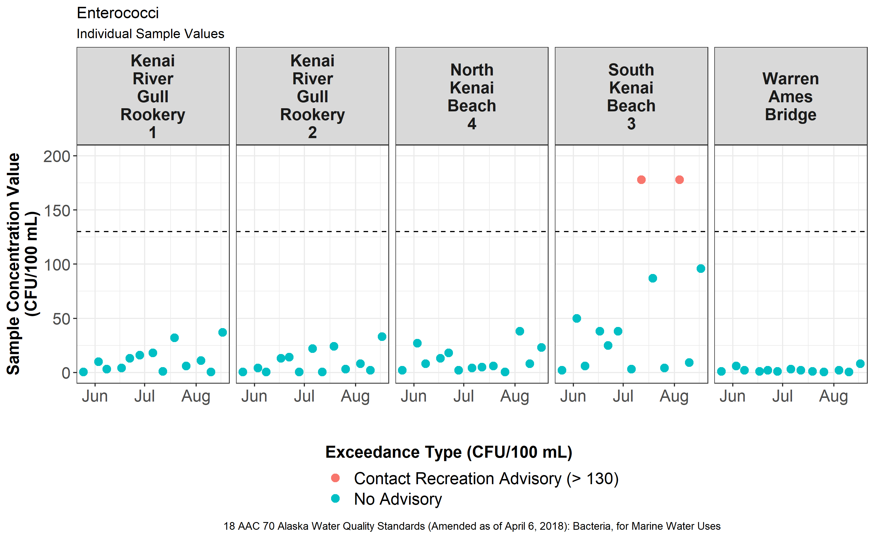

Figure 7 – Enterococci sample concentrations from lower Kenai River sites in 2020, color coded by exceedance standard criteria. Dotted lines indicates the criteria thresholds for individual samples of 130 CFU/100 mL.

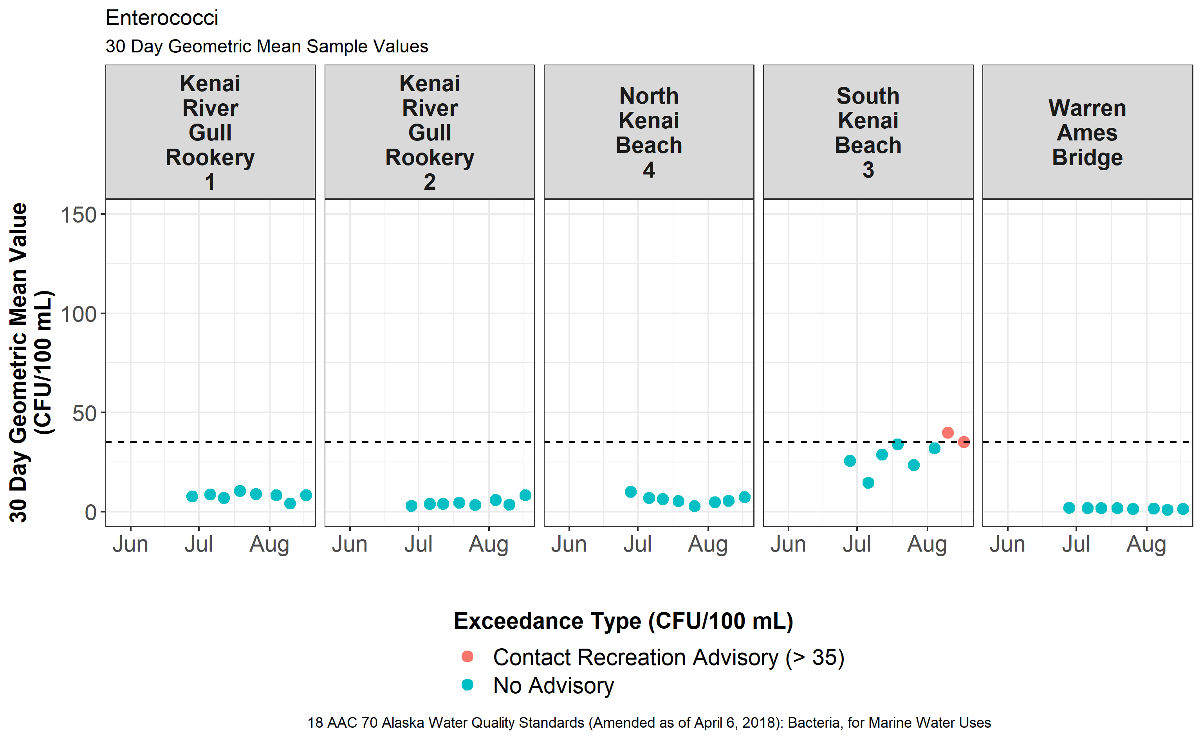

Figure 8 - Thirty day geometric mean values of enterococci samples from lower Kenai River sites in 2020, color coded by exceedance standard criteria. The dotted line indicates criteria threshold of 35 CFU/100 mL for thirty day geometric mean sample values.

Table 7 - Percent of enterococci samples from the 2020 sampling season that exceeded the criteria standard of overall geometric mean of 130 CFU/100 mL.

|  |  |  |  |  |
| --- | --- | --- | --- | --- |
| **Location** | **Standard; Overall Geometric Mean Enterococci, (CFU/100 mL)** | | **% of Samples Above Standard** | **Pass/Fail** |
| Kenai River Gull Rookery 1 | 130 | 0.0% | | pass |
| Kenai River Gull Rookery 2 | 130 | 0.0% | | pass |
| North Kenai Beach 4 | 130 | 0.0% | | pass |
| South Kenai Beach 3 | 130 | 15.4% | | fail |
| Warren Ames Bridge | 130 | 0.0% | | pass |

## **2019 - 2020 Microbial Source Tracking Data**

Sample results for microbial source tracking (MST) were available for two sampling events for each of the 2019 – 2020 sampling seasons. In general, gulls were indicated as the overwhelming source of fecal matter at most sampling events (Figure 9). Concentrations of dog and human feces were detected in some cases, but in general were much lower relative to concentrations of

gull feces. Human fecal matter was detected at one site in 2019 (KRG1) and three sites in 2020 (KRG2, NKB4, SKB3), while dog fecal matter was detected only at the North and South Kenai Beach sites. Concentrations (copies biomarker gene/100 mL) overall ranged from not detected to 28,200 for gulls, not detected to 4,660 for dogs, and not detected to 1,220 for humans.

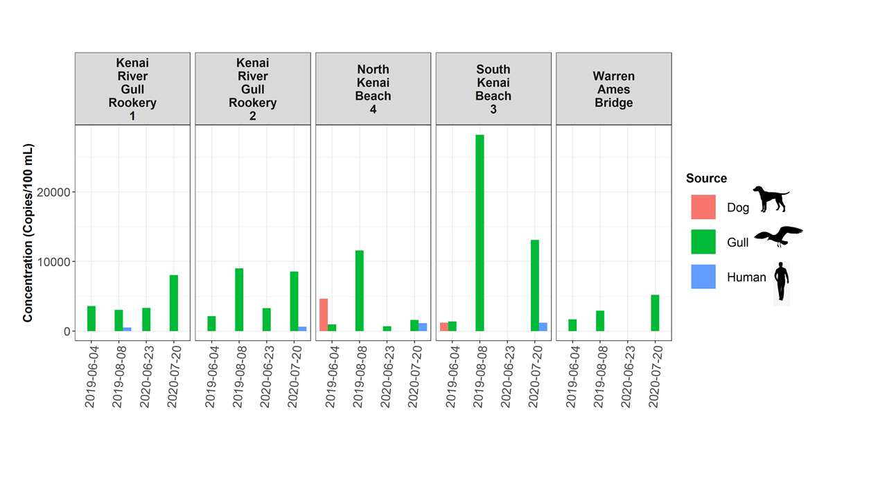

Figure 9: Results from microbial source tracing (MST) analyses from the dive sites sampled for bacteria in the lower Kenai River, 2019 – 2020. Values are copies of biomarker gene per 100 mL. Where colored bars are absent, genetic material was either not detected or detected but not quantifiable. See Appendix F for data used to generate this figure.

While human and dog fecal matter were generally much lower relative to gull fecal matter in most sampling events, several exceptions are noted. Sampling events on June 4, 2019 indicated dog feces as the majority source of fecal contamination at North Kenai beach and as a substantial source, proportionately, at South Kenai Beach. Additionally, on July 7, 2020 at North Kenai beach, fecal matter concentrations for gulls and humans were within a similar range of values, with 1590 marker copies/100 mL for gulls and 1140 marker copies/100 mL for humans (Figure 6). Complete MST data is found in Table 8 (Appendix F: Microbial Source Tracing Data).

# **Discussion**

## **2020 Kenai beach bacteria monitoring**

Enterococci and fecal coliform exceedances occurred in 2020 for in-season criteria as well as overall seasonal criteria.

Individual fecal coliform sample exceedances (> 31 CFU/100 mL) for secondary water recreation were observed at all five sites throughout the 2020 sampling season. Only the South Kenai Beach saw any additional in-season fecal coliform exceedances, which consisted on one secondary water recreation advisory for > 400 CFU/mL. Regarding overall seasonal standards for fecal coliform, all five sites failed one of the overall seasonal standards for harvesting raw aquatic life for consumption (10% of fecal coliform samples > 31 CFU/100 mL), and two out of five sites (Kenai River Gull Rookery 1 and South Kenai Beach) failed the other seasonal standard (overall geometric mean fecal coliform value > 14 CFU/100 mL).

Individual enterococci sample exceedances (> 130 CFU/100 mL) for contact water recreation were observed at South Kenai Beach on two dates in the 2020 sampling season, as well as two dates where the thirty-day geometric mean enterococci value was > 35 CFU/100 mL. Regarding overall seasonal standards for enterococci, one site failed on the overall seasonal standards for contact recreation (10% of enterococci samples > 130 CFU/100 mL).

The elevated concentrations of bacteria at South Kenai Beach relative to other locations can likely be attributed to the increase in fish carcasses and gull fecal matter during the dipnet personal use fishery in July. Though various factors influence the magnitude of bacteria concentrations in the lower Kenai River, the size and timing of the late-run sockeye population and dipnet personal use fishery (PUF) participation are likely among the largest. When more fish carcasses are disposed of on the beach, greater quantities of gull fecal matter contribute to bacteria growth unless mitigated. Annual participation in the Kenai River dipnet personal use fishery (PUF) continues to grow (Figure 10), thus monitoring and assessment of bacteria concentrations in the lower Kenai River will continue to remain essential. Even in spite of the travel challenges posed by the COVID-19 pandemic in summer 2020, overall revenue from – and thus participation in – the dipnet PUF in 2020 was up relative to 2019 ($367,982 in 2019, $456,411 in 2020) (Ostrander, 2020). Although the 2020 harvest was likely lower than 2019 due to the late arrival of a substantial portion of the late-run sockeye in 2020 (Figure 11), in general there is a close relationship between dipnet fishing effort and total annual harvest (Cenek and Franklin, 2017).

An especially valuable exploration of this data would include evaluating the effects of mitigation actions, such as beach raking, on bacteria concentrations, in order to allow managers to most effectively implement this management tool (e.g. Kinzelman et al. 2004). It is important to remember that assessments of best management practices (BMPs) and their effect on frequency and magnitude of exceedances should be evaluated in the context of the growing popularity of the dipnet PUF (Figure 10).

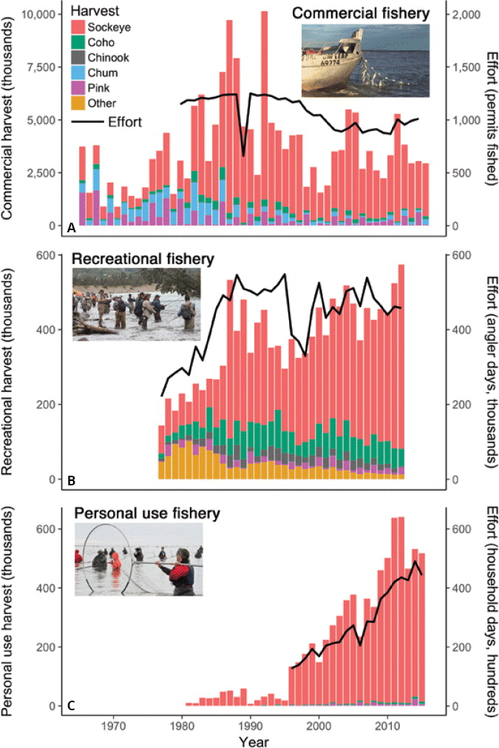

Figure 10 - Growth of the Kenai River personal use fishery in harvest (left axis) and effort (right axis). The fishery has historically captured almost exclusively sockeye salmon (red color), through small numbers of other salmon species are also captured, represented by other colors stacked at the bottom of each bar. Data from ADF&G; figure adapted from Schoen et al. 2017 with author’s permission.

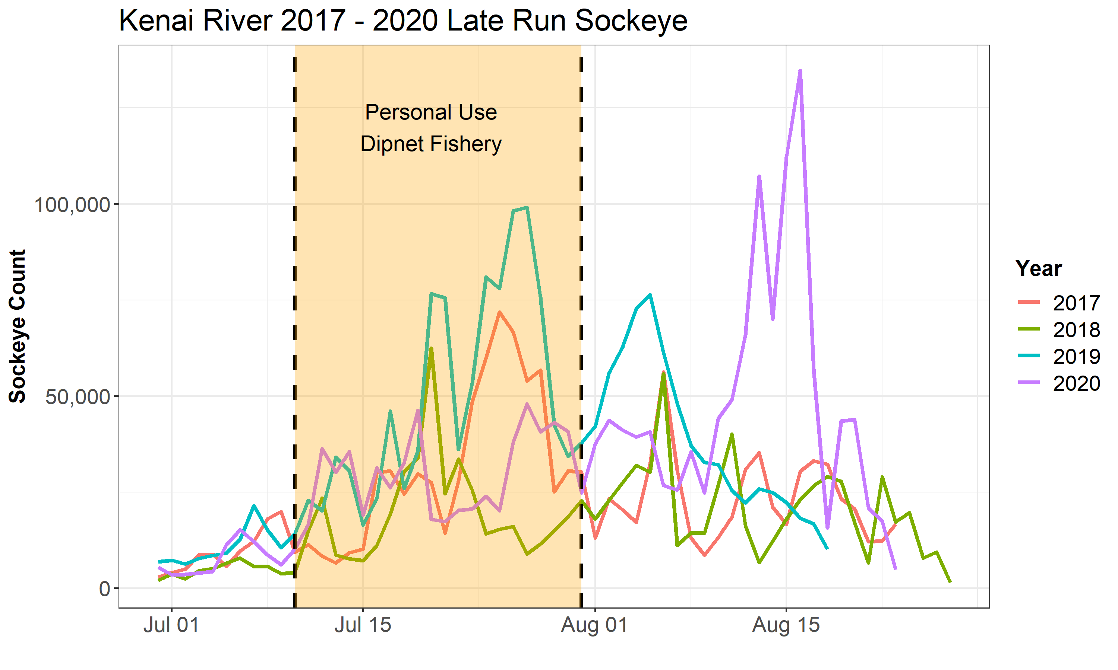

Figure 11 - 2017 – 2020 late run sockeye salmon counts on the Kenai River. Data sourced from Alaska Department of Fish and Game (ADF&G, 2020).

It is recommended that ADEC continue to work closely with the CoK to effectively implement best management practices based on dipnet personal use fishery attendance and beach carcass concentrations. A modification of best management practices to include disposal or compost of carcasses could be a more permanent, effective way to mitigate the effects on bacteria concentrations, and could be the focus of future efforts and partnerships.

Employing the full extent of all available management and environmental data from the lower Kenai River dipnet PUF will be increasingly important in subsequent years, as weekly monitoring of bacteria concentrations move towards less frequent in-situ weekly sample collection (S. Apsens (ADEC), personal communication, 2020a). An implementation of the Environmental Protection Agency's Virtual Beach Model (EPA, 2021c) is planned, and will be used to estimate in-river bacteria concentrations, supported by two to three in situ “spot checks” throughout the summer where physical samples are collected. Moving forward, it is recommended that the full extent of historical data be used to parameterize the Virtual Beach model, and that sufficient data continue to be collected in order to support it, and that the model is regularly evaluated using both in-season spot checks and comparison to hindcasted values.

Some evidence suggests that for this data set, thirty-day geometric means may be a more meaningful value to represent actual in-river conditions than individual sample values. Replicate grab samples of environmental media can be prone to inter- sample variation (Royal Society of Chemistry, 2014). In this report, difference among paired replicate samples averaged approximately 40% for enterococci and 24% for fecal coliform. Previous reports also indicate substantial variation among sample values within a relatively small time span. In 2013, at some sites on North and South Kenai Beach where samples exceeded thresholds, they did not do so when re-sampled twenty-four hours later (Guerron Orejuela, 2013). In 2018, North and South Kenai Beach sites were sampled at hourly intervals for one twenty-four hour cycle in July, and bacteria concentrations varied by an order of magnitude (Harings, 2019). In contrast, criteria that instead assess thirty-day rolling geometric mean values are less prone to short-term variations and thus more likely to represent actual in-river conditions. It is recommended that water quality criteria employing these standards for individual samples do so in the context of mean replicate variation, and be compared to standards that employ rolling geometric means.

Finally, continuing open communication with local stakeholders will remain a critical component of successful and meaningful bacteria monitoring. Emails to stakeholders summarizing weekly sampling results have shown to be effective for conveying data in a transparent manner. Public education and outreach events have also been proven effective, and should continue during future monitoring seasons. Public advisories have reached a broad audience of radio listeners and Facebook viewers. Going forward, it is recommended that the communication protocol is annually reviewed to maintain consistency in when advisories are issued and subsequently removed after two weeks of bacteria concentrations below exceedance threshold (Figure 3 in ADEC, 2020b).

### 2019-2020 Microbial source tracking (MST)

Limited MST data had been gathered during previous Kenai bacteria monitoring events prior to 2019 - 2020. Historically, sample analysis for MST was conducted in 2011 and 2014; results can be found at the [ADEC Beaches Program webpage](https://dec.alaska.gov/water/water-quality/beach-program/past-reports/) (ADEC, 2021). [/](https://dec.alaska.gov/water/water-quality/beach-program/).

MST samples analyzed from the 2019 - 2020 sampling events reported gull host markers at all five sampling sites. Among both years, the highest concentration of marker copies associated with gull fecal matter were detected at both North and South Kenai beach sites. This is likely due to the increase in the number of carcasses (and therefore gulls) along the beaches during the personal use dipnet fishery. For June 2020 MST sampling, both Kenai gull rookery sampling sites displayed higher levels of gull feces than any other site, likely due to their proximity to the rookery itself. Quantifiable results for gull feces were reported at all five sites in July during the dipnet PUF during which marker copies were one order of magnitude higher at South Kenai Beach than any other sampling site.

For comparison among 2019 and 2020, concentration of gull marker copies was roughly twice as high at North and South Kenai Beaches in 2019 than in 2020, which may be attributable to the delayed run timing (and thus likely lower personal use fishery harvest and carcass disposal) of late-run sockeye in 2020.

Finally, it is critical to note that the mouth of the Kenai is a dynamic and ever-changing zone. Influenced by fluctuating river discharge, tides, wind, and boat traffic, patterns in water flow can vary by the minute. Therefore, each MST result is a snapshot of relative species contributions at that time and location.

# **Conclusions and recommendations**

Data collected throughout 2019 and 2020 provide insight into some of the factors involved in the fluctuation of bacteria concentrations in the lower Kenai River and the sources of these bacteria throughout the summer months. Moving forward, the following recommendations should be taken into consideration:

1. In 2020, South Kenai Beach exhibited exceedances of greater frequency magnitude than any other site, with respect to standards for both recreation as well as harvesting seafood for raw consumption. Both North and South Kenai beaches are impacted by an increase in salmon carcasses and therefore gulls during the dipnet personal use fishery.
   1. A basic exploration of patterns in tidal currents and river outflow at the mouth of the Kenai River is recommended, as these patterns may inform the discrepancy in bacteria concentrations between North and South beaches. An examination of satellite imagery may be sufficient to describe patterns of sedimentation and currents at the mouth of the Kenai that influence bacteria concentrations.
   2. It is recommended that ADEC work with the City of Kenai to assess the effectiveness of current best management practices (BMPs) and modify if necessary. With a long-term time series, the effectiveness of BMPs may be evident in the data, though trends should be evaluated in the context of the growth of the personal use fishery in the past two decades. One modification of best management practices could include requiring the immediate disposal or composting of carcasses on the beach.
2. Consistent communication with stakeholders and user groups will remain critical to effective beach monitoring. Communication protocol should be annually reviewed to ensure consistency in when public advisories are issued and for what sites they are necessary.
3. In the future, annual reports should evaluate annual results in the context of available long-term data sets. Comparing new data to long term trends is essential to ensure that ecological trends are readily recognizable even as staff and personnel involved with monitoring may change.
4. Using the results of the Environmental Protection Agency’s Virtual Beach Model, it is advised that a monitoring program be operated in perpetuity in order to issue public advisories when necessary.

These four actions would support educated management decisions, encourage preservation of environmental habitat, mitigate potential public health issues, and ensure transparency of the beach monitoring process.

# **Data availability**

All data and R programming scripts used in this analysis is available in a public repository at <https://github.com/Kenai-Watershed-Forum/KWF_Beach_Sampling_2019_2020>.

# **References**

5 AAC 21.360, Alaska Admin Code. (2020). *Kenai River Late Run Sockeye Salmon Management Plan*. <http://www.legis.state.ak.us/basis/aac.asp#5.21.360>.

Alaska Department of Environmental Conservation (ADEC). (2018). *2018 Water Quality Standards*.

Alaska Department of Environmental Conservation (ADEC). (2012). *Kenai BEACH Water Quality Monitoring and Pathogen Detection: Quality Assurance Project Plan, Rev. 3*.

Alaska Department of Environmental Conservation (ADEC). (2012). *Kenai BEACH Water Quality Monitoring and Pathogen Detection: Quality Assurance Project Plan, Rev. 4*.

Alaska Department of Environmental Conservation (ADEC). (2019). *Alaska Consolidated Assessment and Listing Methodology (CALM) for 2020 Integrated Report on Water Quality.*

<https://dec.alaska.gov/media/15688/alaska-consolidated-assessment-listing-methodology-for-2020-integrated-report.pdf>

Alaska Department of Environmental Conservation (ADEC). (2020a). Personal communication on 2021 bacteria monitoring program, S. Apsens, December 2020.

Alaska Department of Environmental Conservation (ADEC). (2020b). *Beach Monitoring Handbook Kenai River Beaches, Rev. 3.* <https://dec.alaska.gov/media/20323/2020-kenai-beach-sampling-handbook.pdf>

Alaska Department of Environmental Conservation (ADEC). (2020c). *Kenai BEACH Water Quality Monitoring and Pathogen Detection: Quality Assurance Project Pan, Rev. 4*.

[https://github.com/Kenai-Watershed-Forum/KWF\_Beach\_Sampling\_2019\_2020/blob/main/ documents/2020%20Kenai%20BEACH%20QAPP\_2020.docx](https://github.com/Kenai-Watershed-Forum/KWF_Beach_Sampling_2019_2020/blob/main/%20documents/2020%20Kenai%20BEACH%20QAPP_2020.docx)

Alaska Department of Environmental Conservation (ADEC). (2021). *Alaska BEACH Grant Program.* <https://dec.alaska.gov/water/water-quality/beach-program/>

Alaska Department of Fish and Game. (2018). *Kenai River boat and shore dipnet areas* [Digital image]. Retrieved December 12, 2018, from [www.adfg.alaska.gov/index.cfm?adfg=personalusebyareasouthcentralkenaisalmon.main](http://www.adfg.alaska.gov/index.cfm?adfg=personalusebyareasouthcentralkenaisalmon.main).

Alaska Department of Fish and Game. (2020). Kenai River late-run sockeye. <https://www.adfg.alaska.gov/sf/FishCounts/>. Accessed January 11, 2021.

# Alaska Department of Fish and Game. (2021). Cook Inlet Personal Use Fisheries Salmon Fishery Harvest and Effort Estimates. Accessed February 4, 2021. <https://www.adfg.alaska.gov/index.cfm?adfg=PersonalUsebyAreaSouthcentralKenaiSalmon.harvest>

Cenek, M., Franklin, M. (2017). *An adaptable agent-based model for guiding multi-species Pacific salmon fisheries management within a SES framework*. Ecological Modelling **2017**, *360*(24), 132-149, <https://doi.org/10.1016/j.ecolmodel.2017.06.024>.

Environmental Protection Agency (EPA). 2021a. Submitting Beach Data to EPA. <https://www.epa.gov/beach-tech/submitting-beach-data-epa>. Accessed Jan 8, 2021.

Environmental Protection Agency (EPA). 2021b. EPA BEACON. <https://watersgeo.epa.gov/beacon2/>. Accessed January 8, 2021.

Environmental Protection Agency (EPA). 2021c. Environmental Modeling Community of Practice: Virtual Beach. <https://www.epa.gov/ceam/virtual-beach-vb>. Accessed January 11, 2021.

Guerron Orejuela, E. (2014). City of Kenai Kenai River Beach Sampling FY 2014 Final Report. <https://scholarcommons.usf.edu/geo_studpub/76/>. Accessed January 11, 2021.

Green, H., Welker, D., Johnson, S., Michalenko, E. (2019). Microbial Source-Tracking Reveals Origins of Fecal Contamination in a Recovering Watershed. Water, 11(10), 2162. <https://doi.org/10.3390/w11102162>.

Harings, M. (2020). 2018-2019 Kenai Beach Bacteria Monitoring Report. Kenai Watershed Forum. <https://dec.alaska.gov/media/21000/kenai-river-beach-2019-final-reportadec.pdf>. Accessed January 11, 2021.

Kinzelman, J.L., Pond, K. R., Longmaid, K. D., Bagley, R. C. (2004). The effect of two mechanical beach grooming strategies on *Escherichia coli* density in beach sand at a southwestern Lake Michigan beach. *Aquatic Ecosystem Health & Management, 7*(3), 425-432. <https://doi.org/0.1080/14634980490483953>

Ostrander, P. (2019). *2019 Personal Use Fishery (Dip Net) Report*. Kenai, Alaska: City of Kenai.

Ostrander, P. (2020). *2020 Personal Use Fishery (Dip Net) Report*. Kenai, Alaska: City of Kenai.

Royal Society of Chemistry. (2014*). Estimating sampling uncertainty–how many duplicate samples are needed?* Analytical Methods, 6(24), 24-26. <https://www.rsc.org/images/sampling-uncertainty-58_tcm18-237148.pdf>.

Schoen, E. R., Wipfli, M. S., Trammell, E. J., Rinella, D. J., Floyd, A. L., Grunblatt, J., McCarthy, M. D., Meyer, B. E., Morton, J. M., Powell, J. E., Prakash, A., Reimer, M. N., Stuefer, S. L., Toniolo, H., Wells, B. M., & Witmer, F. D. W. (2017). Future of pacific salmon in the face of environmental change: Lessons from one of the world’s remaining productive salmon regions. *Fisheries*, *42*(10), 538–553. [https://doi.org/10.1080/03632415.2017.1374251](http://dx.doi.org/10.1080/03632415.2017.1374251)

## **Appendix A: Site Photographs**

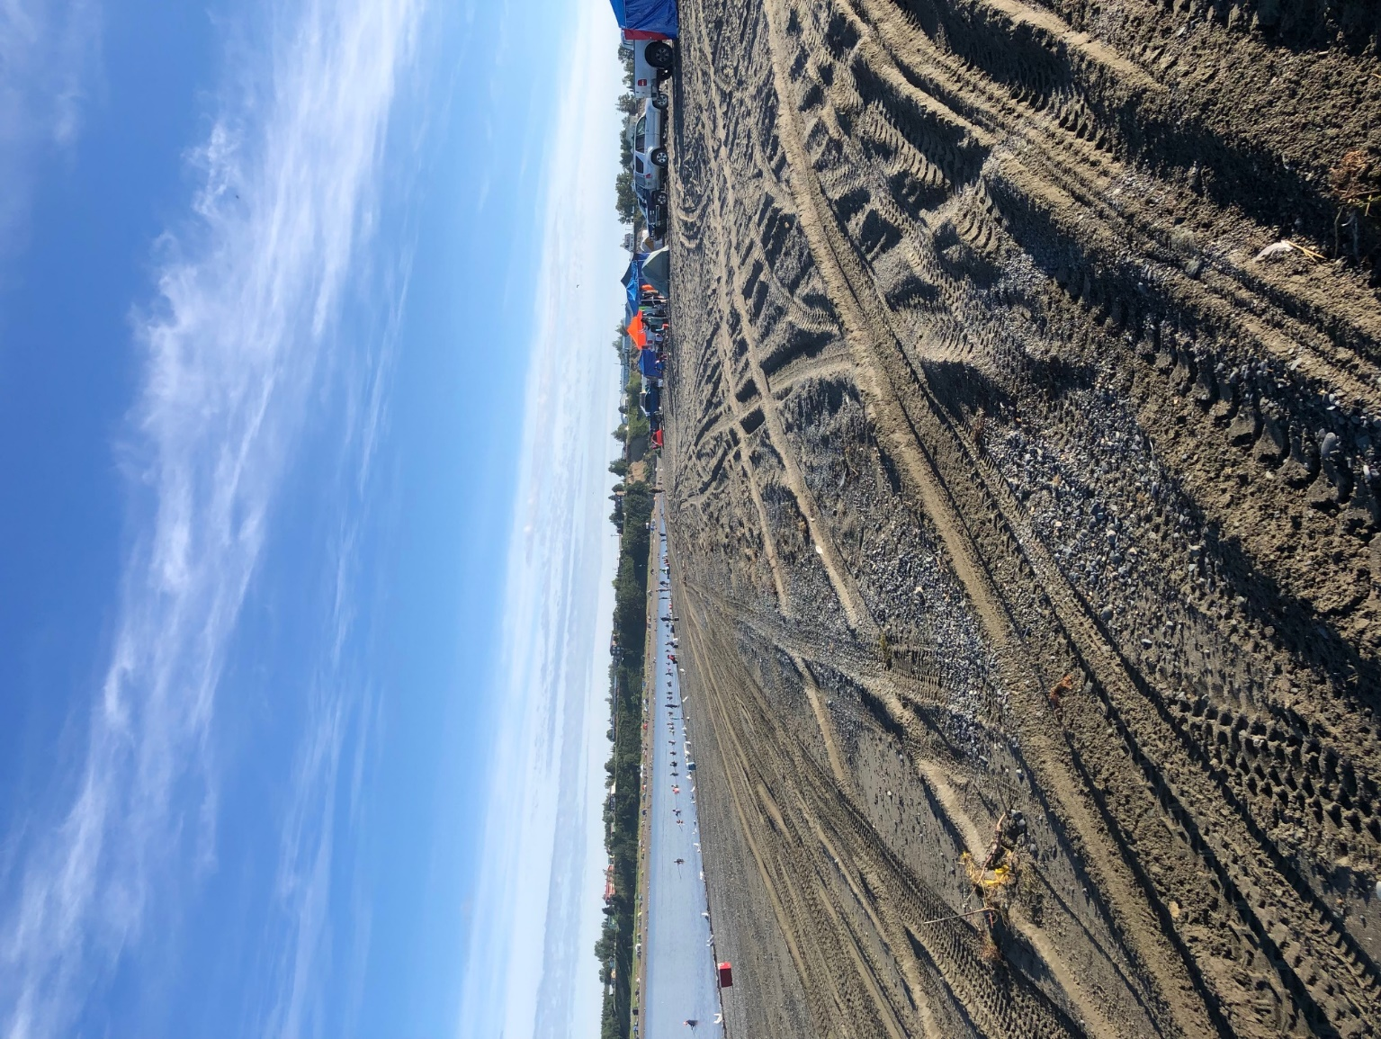

South Kenai Beach 3 sampling location looking toward the Kenai River outlet. North Kenai Beach can be seen in the background. Photo taken on July 27, 2020 during the personal use dipnet fishery season.

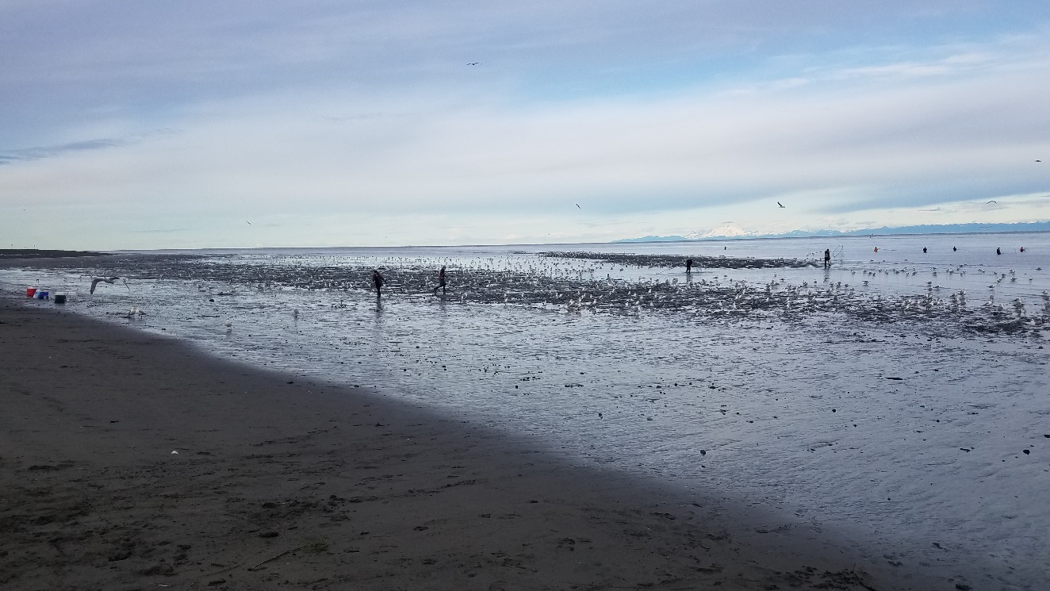

South Kenai Beach 3 sampling location depicting the highest gull count of the sampling season. Photo taken on July 20, 2020 during the personal use dipnet fishery season.

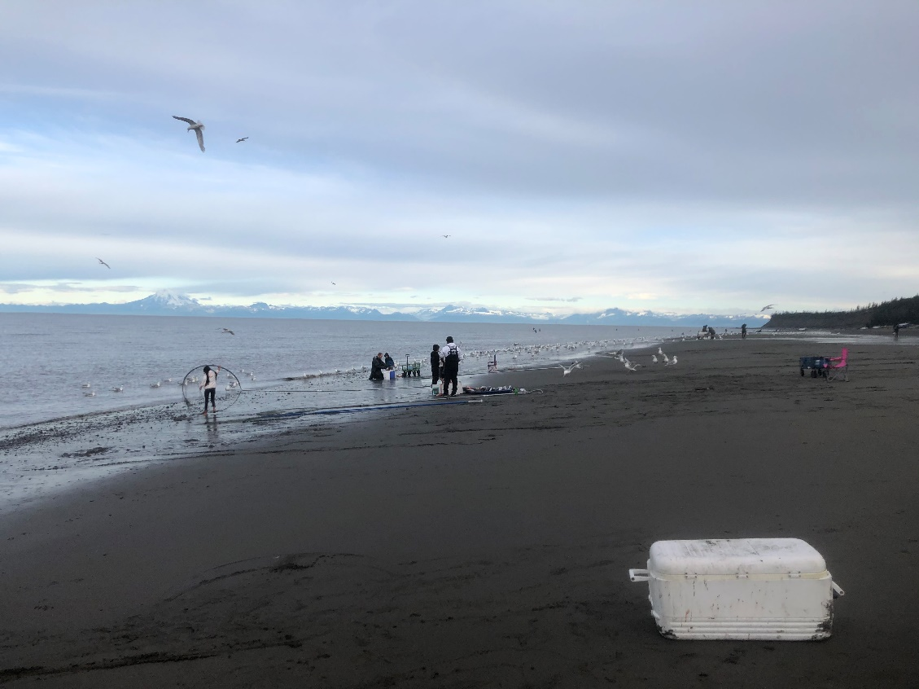

North Kenai Beach 4 sampling location. Photo taken on July 20, 2020 during the personal use dipnet fishery season.

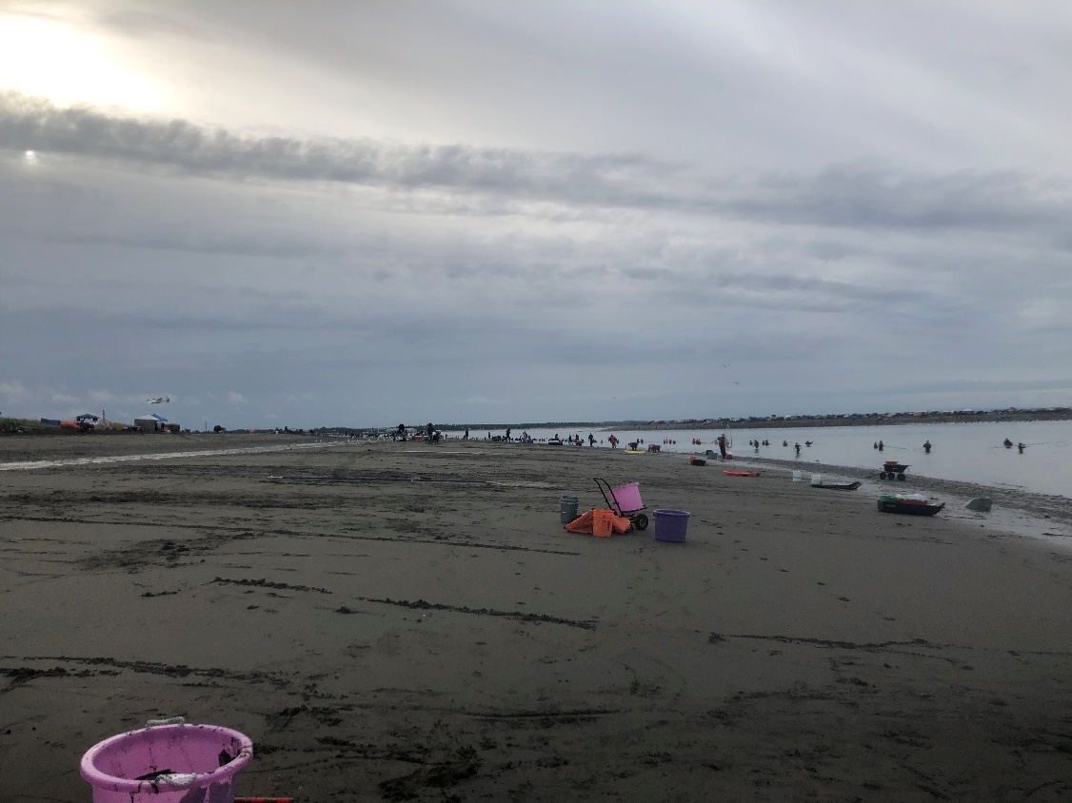

North Kenai Beach 4 sampling location looking away from the Kenai River outlet. Photo taken on July 23, 2019 during the personal use dipnet fishery season.

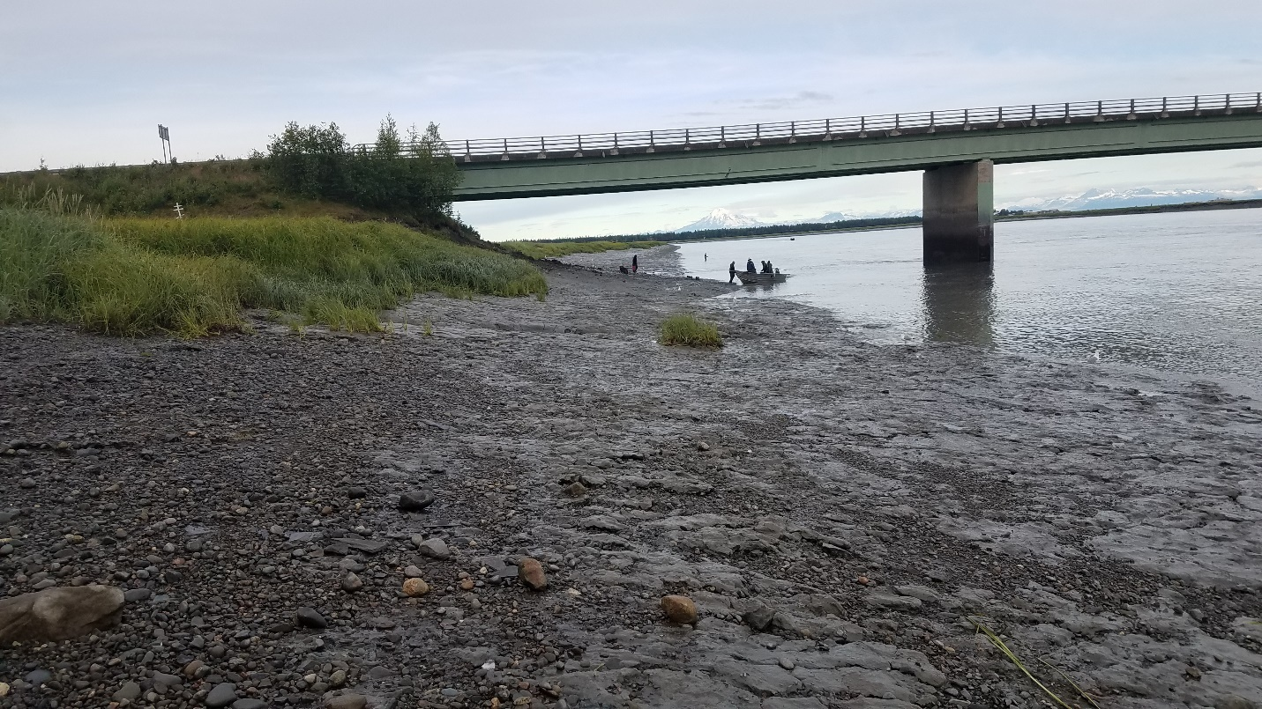

Warren Ames Memorial Bridge 1 sampling location looking downstream on the Kenai River. Photo taken on July 20, 2020 during the personal use dipnet fishery season.

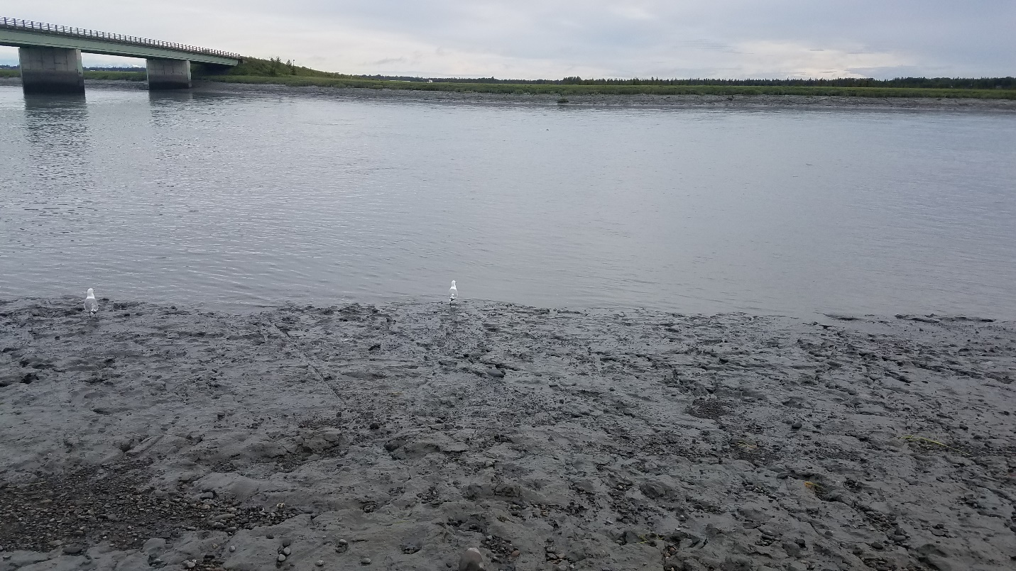

Warren Ames Memorial Bridge 1 sampling location on the Kenai River. Photo taken on July 20, 2020 during the personal use dipnet fishery season.

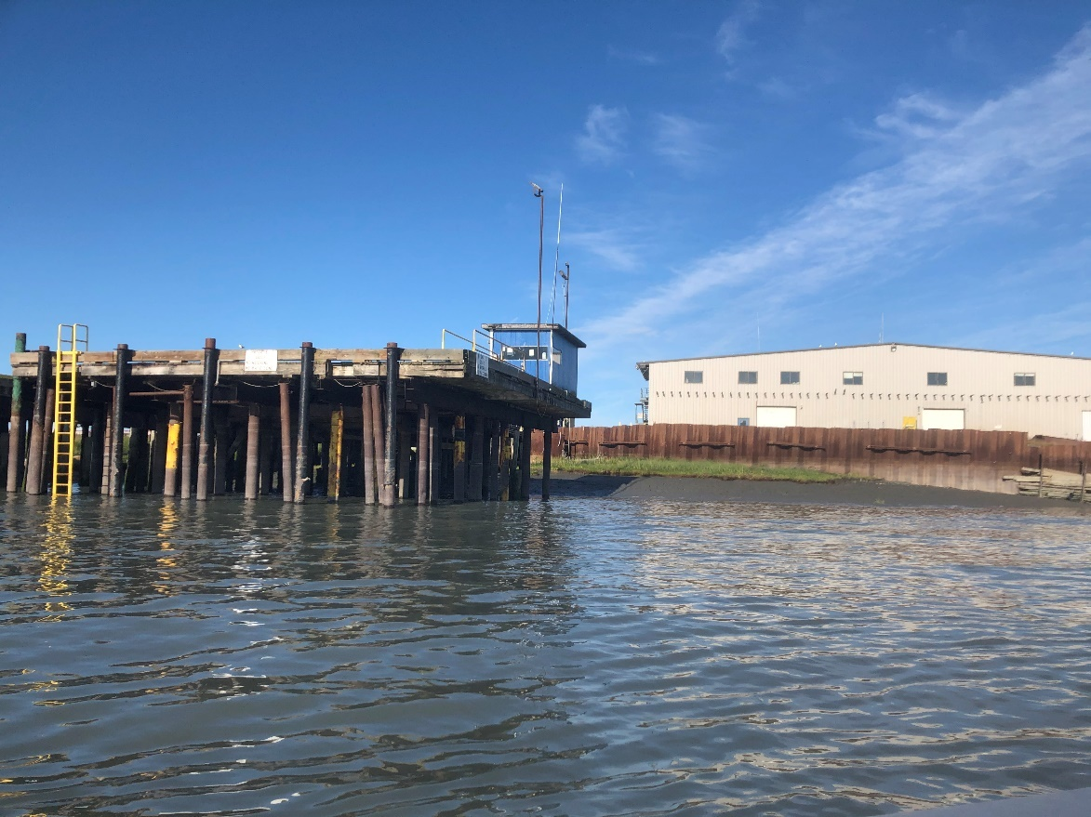

Kenai Gull Rookery 1 sampling location. The fish processing plant can be seen in the background. Photo taken on July 27, 2020 during the personal use dipnet fishery season.

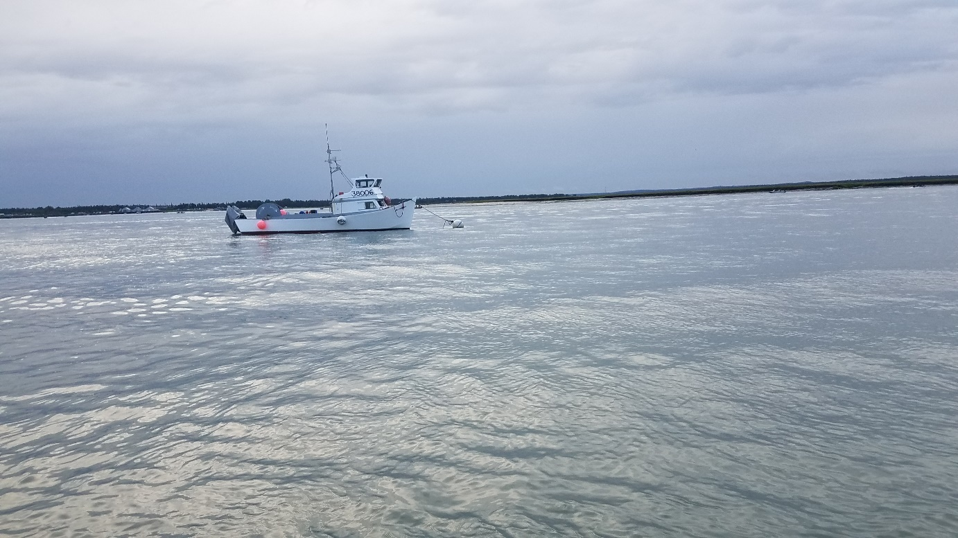

Kenai Gull Rookery 1 sampling location looking across the Kenai River. Dipnetting boats can be seen along the far shore behind the mooring boat. Photo taken on July 20, 2020 during the personal use dipnet fishery season.

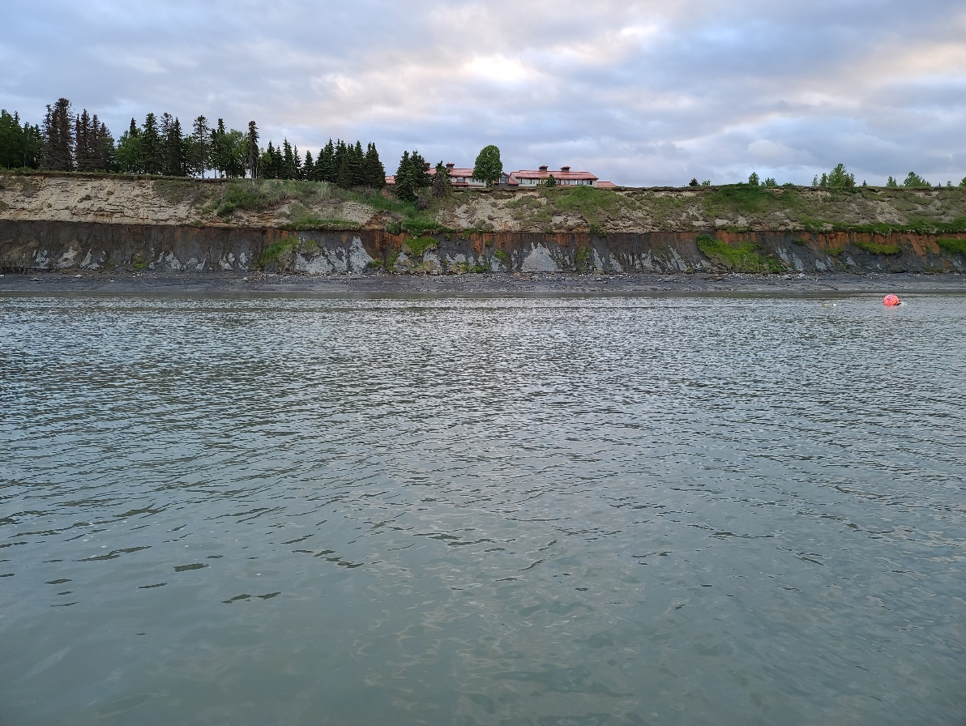

Kenai Gull Rookery 2 sampling location looking at river-right bank. Photo taken on June 18, 2020.

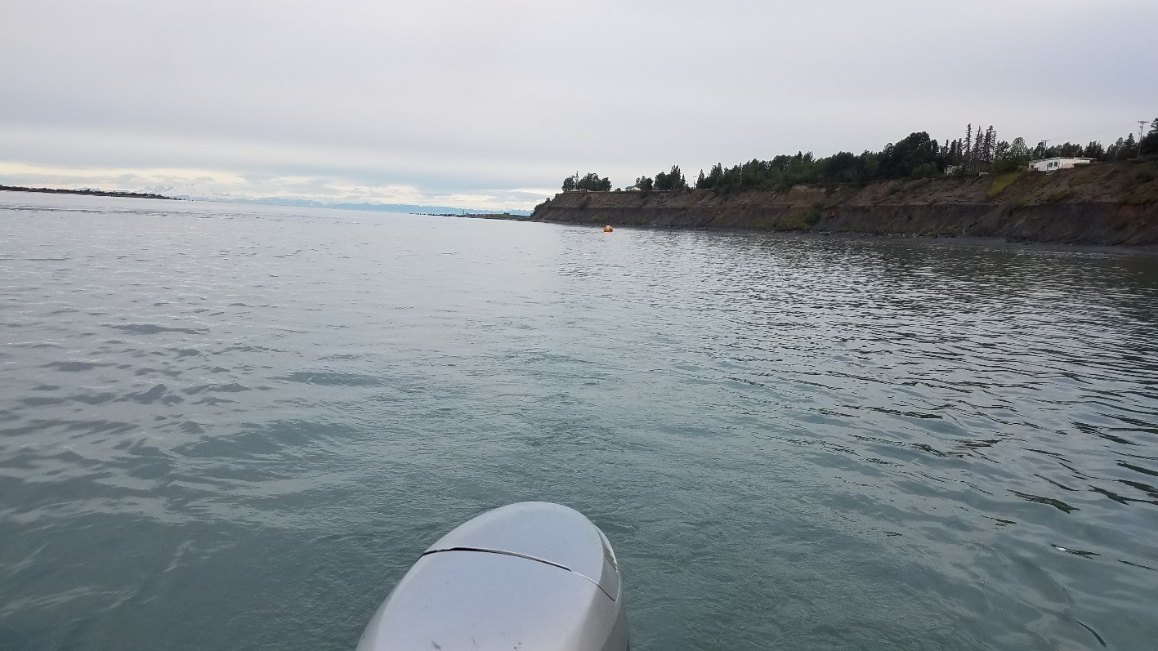

Kenai Gull Rookery 2 sampling location looking downstream toward Kenai River outlet and Cook Inlet. Photo taken on July 20, 2020 during the personal use dipnet fishery season.

## **Appendix B: Press Releases (Page 1 of 5)**

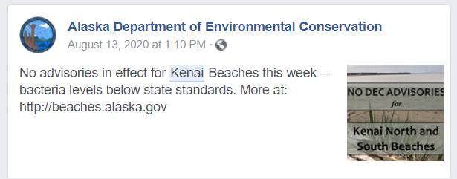

Example of advisory notice post on the ADEC Alaska Facebook page.

Appendix B: Press Releases (Page 2 of 5)

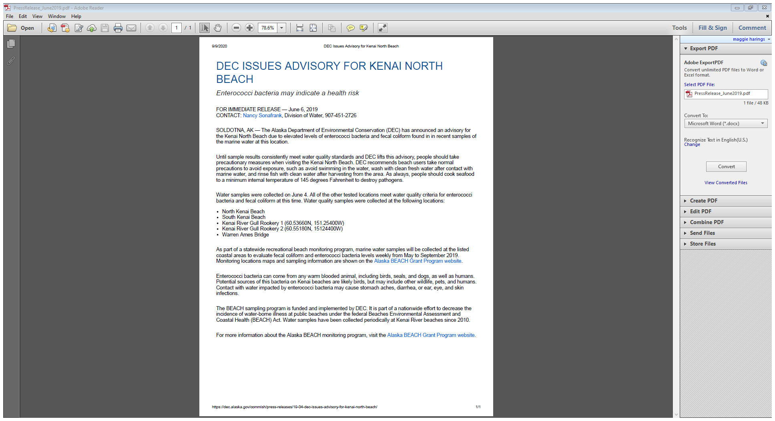

Appendix B: Press Releases (Page 3 of 5)

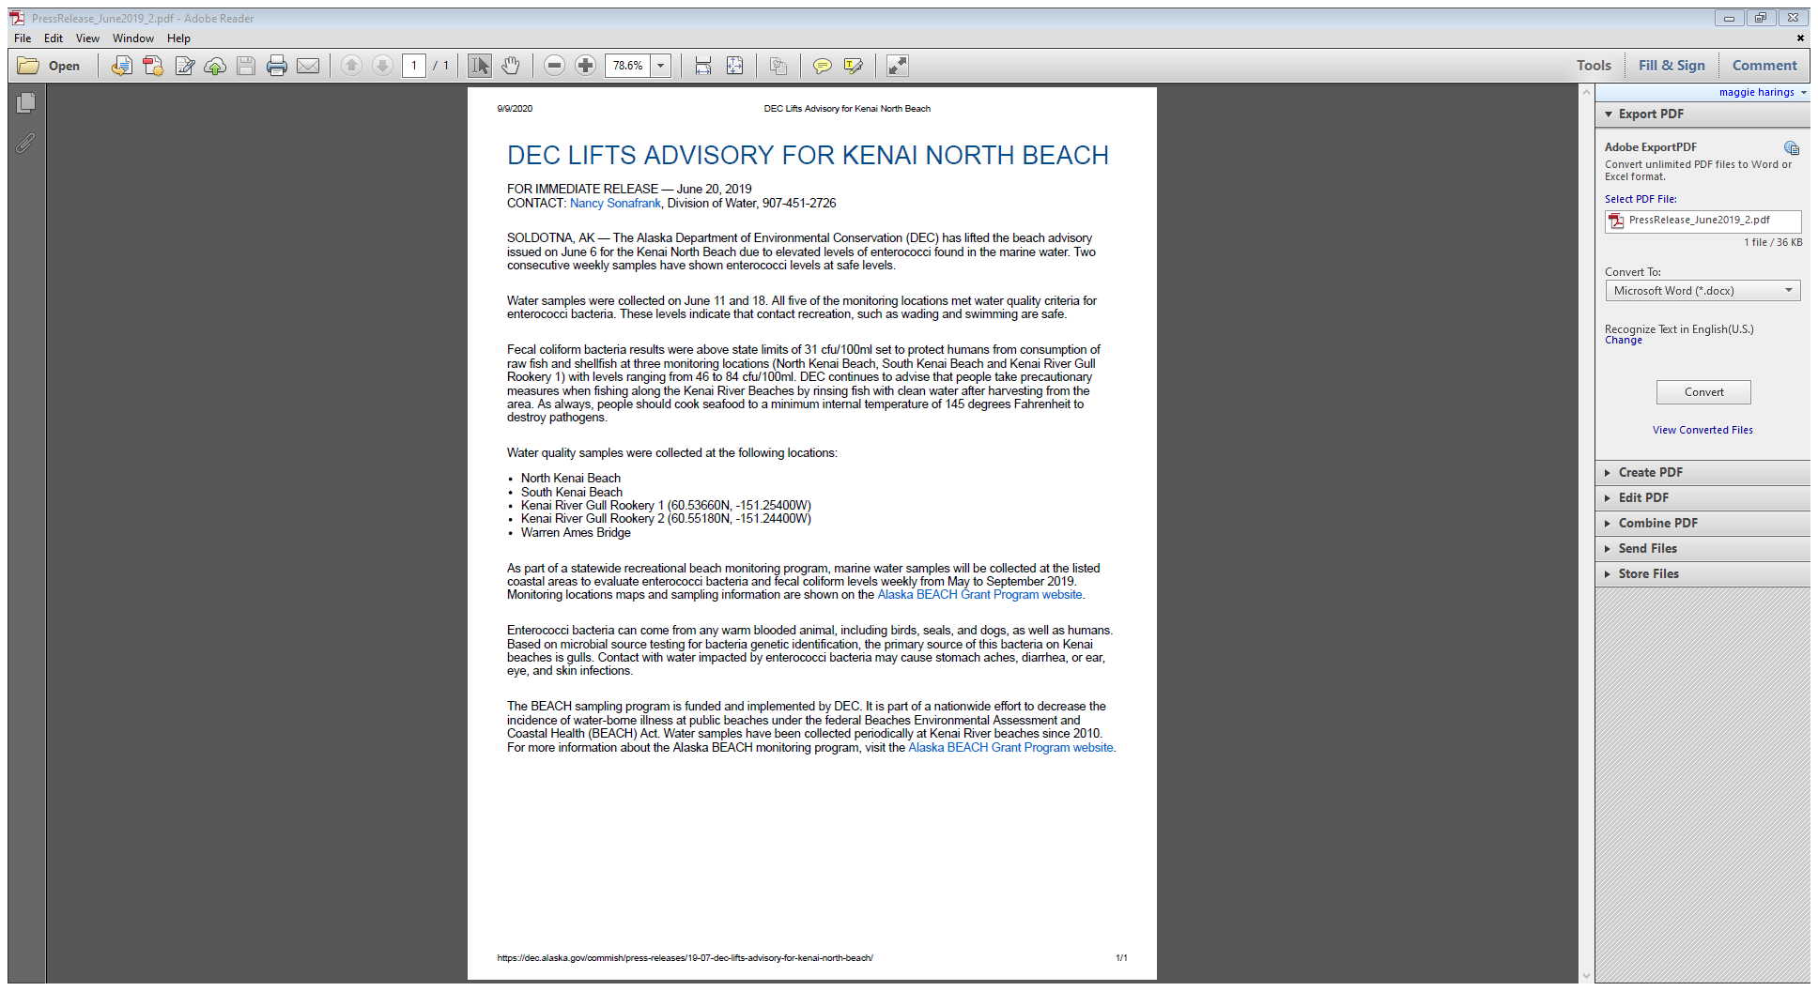

Appendix B: Press Releases (Page 4 of 5)

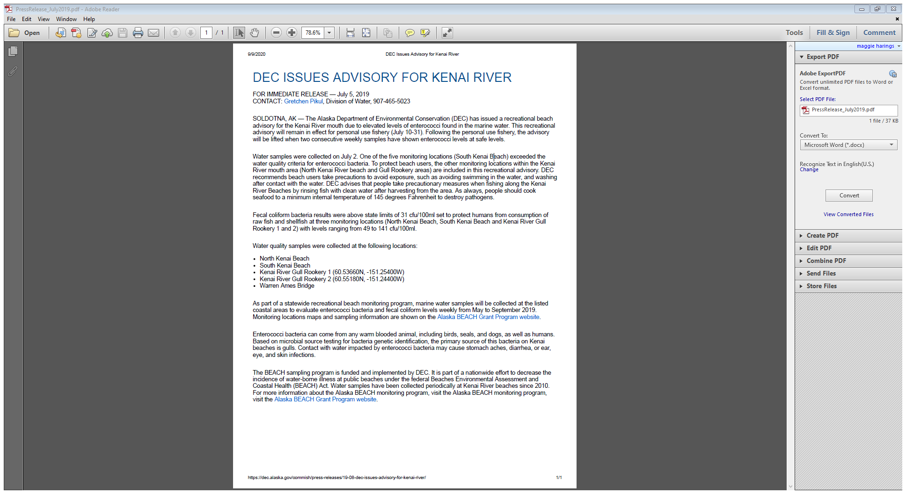

Appendix B: Press Releases (Page 5 of 5)

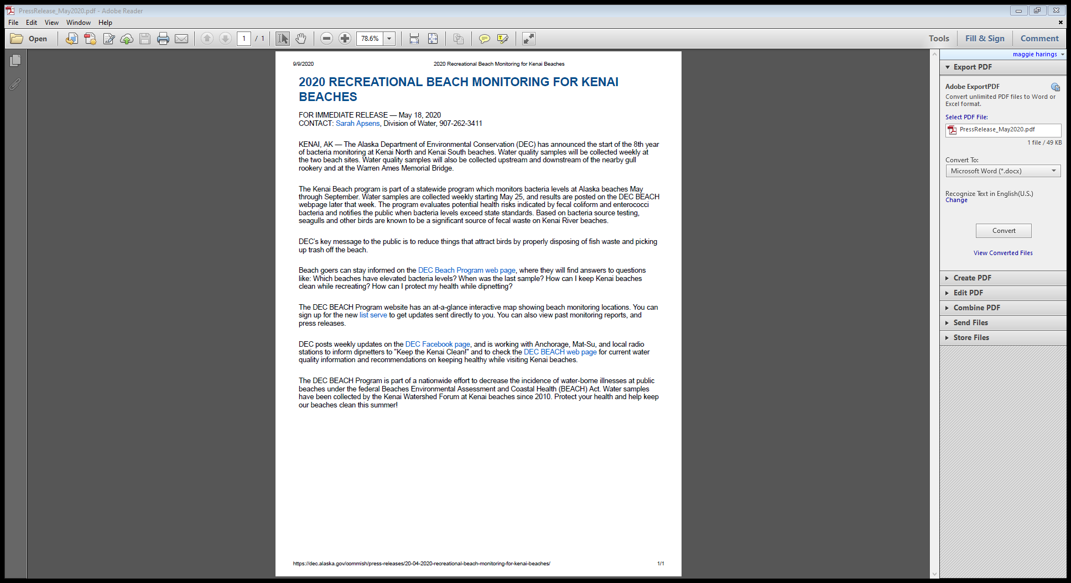

## **Appendix C: Chain-of-Custody**



## **Appendix D: Marine Beach Sanitary Survey**

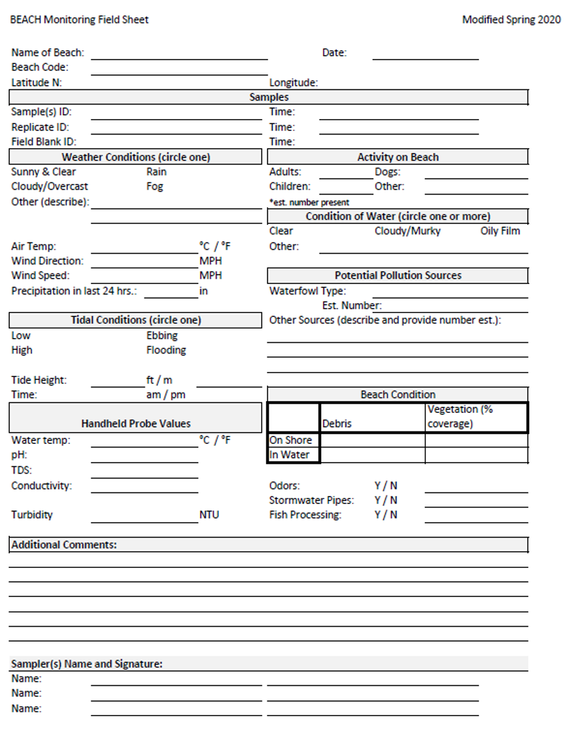

## **Appendix E: 2020 Samples Values and Exceedances (Page 1 of 6)**

|  |  |  |  |  |  |  |
| --- | --- | --- | --- | --- | --- | --- |
| **Bacteria** | **Location** | **Date** | **Individual Sample Value (CFU/100 mL)** | **30 Day Rolling Geometric Mean Value (CFU/100 mL)** | **Individual Sample Value Exceedance** | **30 Day Geometric Mean Exceedance** |
| Enterococci | Kenai River Gull Rookery 1 | 5/26/2020 | 0.5 |  |  |  |
| 6/4/2020 | 10 |  |  |  |
| 6/9/2020 | 3 |  |  |  |
| 6/18/2020 | 4 |  |  |  |
| 6/23/2020 | 13 |  |  |  |
| 6/29/2020 | 16 | 7.6 |  |  |
| 7/7/2020 | 18 | 8.5 |  |  |
| 7/13/2020 | 1 | 6.8 |  |  |
| 7/20/2020 | 32 | 10.4 |  |  |
| 7/27/2020 | 6 | 8.9 |  |  |
| 8/5/2020 | 11 | 8.2 |  |  |
| 8/11/2020 | 0.5 | 4.0 |  |  |
| 8/18/2020 | 37 | 8.3 |  |  |
| Kenai River Gull Rookery 2 | 5/26/2020 | 0.5 |  |  |  |
| 6/4/2020 | 4 |  |  |  |
| 6/9/2020 | 0.5 |  |  |  |
| 6/18/2020 | 13 |  |  |  |
| 6/23/2020 | 14 |  |  |  |
| 6/29/2020 | 0.5 | 2.8 |  |  |
| 7/7/2020 | 22 | 4.0 |  |  |
| 7/13/2020 | 0.5 | 4.0 |  |  |
| 7/20/2020 | 24 | 4.5 |  |  |
| 7/27/2020 | 3 | 3.3 |  |  |
| 8/5/2020 | 8 | 5.8 |  |  |
| 8/11/2020 | 2 | 3.6 |  |  |
| 8/18/2020 | 33 | 8.2 |  |  |
| North Kenai Beach 4 | 5/26/2020 | 2 |  |  |  |
| 6/4/2020 | 27 |  |  |  |
| 6/9/2020 | 8 |  |  |  |
|  | | | | | | |
| **Individual Enterococci Samples > 130 CFU/100 mL** | | | | | | |
| **30 Day Geometric Mean Enterococci Value > 35 CFU/100 mL** | | | | | | |

**Appendix E: 2020 Sample Values and Exceedances (Page 2 of 6)**

|  |  |  |  |  |  |  |
| --- | --- | --- | --- | --- | --- | --- |
| **Bacteria** | **Location** | **Date** | **Individual Sample Value (CFU/100 mL)** | **30 Day Rolling Geometric Mean Value (CFU/100 mL)** | **Individual Sample Value Exceedance** | **30 Day Geometric Mean Exceedance** |
| Enterococci | North Kenai Beach 4 | 6/18/2020 | 13 |  |  |  |
| 6/23/2020 | 18 |  |  |  |
| 6/29/2020 | 2 | 10.0 |  |  |
| 7/7/2020 | 4 | 6.8 |  |  |
| 7/13/2020 | 5 | 6.2 |  |  |
| 7/20/2020 | 6 | 5.3 |  |  |
| 7/27/2020 | 0.5 | 2.6 |  |  |
| 8/5/2020 | 38 | 4.7 |  |  |
| 8/11/2020 | 8 | 5.4 |  |  |
| 8/18/2020 | 23 | 7.3 |  |  |
| South Kenai Beach 3 | 5/26/2020 | 2 |  |  |  |
| 6/4/2020 | 50 |  |  |  |
| 6/9/2020 | 6 |  |  |  |
| 6/18/2020 | 38 |  |  |  |
| 6/23/2020 | 25 |  |  |  |
| 6/29/2020 | 38 | 25.5 |  |  |
| 7/7/2020 | 3 | 14.5 |  |  |
| 7/13/2020 | 178 | 28.6 | > 130 |  |
| 7/20/2020 | 87 | 33.8 |  |  |
| 7/27/2020 | 4 | 23.4 |  |  |
| 8/5/2020 | 178 | 31.9 | > 130 |  |
| 8/11/2020 | 9 | 39.7 |  | > 35 |
| 8/18/2020 | 96 | 35.1 |  | > 35 |
| Warren Ames Bridge | 5/26/2020 | 1 |  |  |  |
| 6/4/2020 | 6 |  |  |  |
| 6/9/2020 | 2 |  |  |  |
| 6/18/2020 | 1 |  |  |  |
| 6/23/2020 | 2 |  |  |  |
| 6/29/2020 | 1 | 1.9 |  |  |
|  | | | | | | |
| **Individual Enterococci Samples > 130 CFU/100 mL** | | | | | | |
| **30 Day Geometric Mean Enterococci Value > 35 CFU/100 mL** | | | | | | |

**Appendix E: 2020 Sample Values and Exceedances**

**(Page 3 of 6)**

|  |  |  |  |  |  |  |
| --- | --- | --- | --- | --- | --- | --- |
| **Bacteria** | **Location** | **Date** | **Individual Sample Value (CFU/100 mL)** | **30 Day Rolling Geometric Mean Value (CFU/100 mL)** | **Individual Sample Value Exceedance** | **30 Day Geometric Mean Exceedance** |
| Enterococci | Warren Ames Bridge | 7/7/2020 | 3 | 1.6 |  |  |
| 7/13/2020 | 2 | 1.6 |  |  |
| 7/20/2020 | 1 | 1.6 |  |  |
| 7/27/2020 | 0.5 | 1.2 |  |  |
| 8/5/2020 | 2 | 1.4 |  |  |
| 8/11/2020 | 0.5 | 1.0 |  |  |
| 8/18/2020 | 8 | 1.3 |  |  |
|  | | | | | | |
| **Individual Enterococci Samples > 130 CFU/100 mL** | | | | | | |
| **30 Day Geometric Mean Enterococci Value > 35 CFU/100 mL** | | | | | | |

**Appendix E: 2020 Sample Values and Exceedances (Page 4 of 6)**

|  |  |  |  |  |  |  |
| --- | --- | --- | --- | --- | --- | --- |
| **Bacteria** | **Location** | **Date** | **Individual Sample Value (CFU/100 mL)** | **30 Day Rolling Geometric Mean Value (CFU/100 mL)** | **Individual Sample Value Exceedance** | **30 Day Geometric Mean Exceedance** |
| Fecal Coliform | Kenai River Gull Rookery 1 | 5/26/2020 | 1 |  |  |  |
| 6/4/2020 | 12 |  |  |  |
| 6/9/2020 | 9.3 |  |  |  |
| 6/18/2020 | 38 |  | > 31 |  |
| 6/23/2020 | 62 |  | > 31 |  |
| 6/29/2020 | 310 | 38.2 | > 31 |  |
| 7/7/2020 | 84 | 56.4 | > 31 |  |
| 7/13/2020 | 17 | 63.6 |  |  |
| 7/20/2020 | 280 | 94.9 | > 31 |  |
| 7/27/2020 | 52 | 91.6 | > 31 |  |
| 8/5/2020 | 57 | 65.3 | > 31 |  |
| 8/11/2020 | 3 | 33.5 |  |  |
| 8/18/2020 | 76 | 45.2 | > 31 |  |
| Kenai River Gull Rookery 2 | 5/26/2020 | 0.5 |  |  |  |
| 6/4/2020 | 9.3 |  |  |  |
| 6/9/2020 | 12 |  |  |  |
| 6/18/2020 | 31 |  | > 31 |  |
| 6/23/2020 | 28 |  |  |  |
| 6/29/2020 | 3.3 | 12.6 |  |  |
| 7/7/2020 | 50 | 17.7 | > 31 |  |
| 7/13/2020 | 15 | 18.5 |  |  |
| 7/20/2020 | 40 | 19.4 | > 31 |  |
| 7/27/2020 | 10 | 15.8 |  |  |
| 8/5/2020 | 29 | 24.4 |  |  |
| 8/11/2020 | 19 | 20.1 |  |  |
| 8/18/2020 | 27 | 22.6 |  |  |
| North Kenai Beach 4 | 5/26/2020 | 2 |  |  |  |
| 6/4/2020 | 36 |  | > 31 |  |
| 6/9/2020 | 7.7 |  |  |  |
| 6/18/2020 | 54 |  | > 31 |  |
|  | | | | | |  |
| **Individual Fecal Coliform Samples > 31 CFU/100 mL** | | | | | | |
| **Individual Fecal Coliform Samples > 400 CFU/100 mL** | | | | | | |

**Appendix E: 2020 Sample Values and Exceedances (Page 5 of 6)**

|  |  |  |  |  |  |  |
| --- | --- | --- | --- | --- | --- | --- |
| **Bacteria** | **Location** | **Date** | **Individual Sample Value (CFU/100 mL)** | **30 Day Rolling Geometric Mean Value (CFU/100 mL)** | **Individual Sample Value Exceedance** | **30 Day Geometric Mean Exceedance** |
| Fecal Coliform | North Kenai Beach 4 | 6/23/2020 | 14 |  |  |  |
| 6/29/2020 | 2.9 | 14.3 |  |  |
| 7/7/2020 | 3.3 | 8.9 |  |  |
| 7/13/2020 | 29 | 11.6 |  |  |
| 7/20/2020 | 31 | 10.4 | > 31 |  |
| 7/27/2020 | 2 | 7.0 |  |  |
| 8/5/2020 | 31 | 11.3 | > 31 |  |
| 8/11/2020 | 43 | 18.9 | > 31 |  |
| 8/18/2020 | 42 | 20.3 | > 31 |  |
| South Kenai Beach 3 | 5/26/2020 | 4 |  |  |  |
| 6/4/2020 | 69 |  | > 31 |  |
| 6/9/2020 | 3.845 |  |  |  |
| 6/9/2020 | 7.7 |  |  |  |
| 6/18/2020 | 46 |  | > 31 |  |
| 6/23/2020 | 49 |  | > 31 |  |
| 6/29/2020 | 5.7 | 17.2 |  |  |
| 7/7/2020 | 13 | 13.1 |  |  |
| 7/13/2020 | 600 | 39.8 | > 400 |  |
| 7/20/2020 | 196 | 53.2 | > 31 |  |
| 7/27/2020 | 8.6 | 37.6 |  |  |
| 8/5/2020 | 184 | 75.3 | > 31 |  |
| 8/11/2020 | 17 | 79.4 |  |  |
| 8/18/2020 | 153 | 60.4 | > 31 |  |
| Warren Ames Bridge | 5/26/2020 | 3 |  |  |  |
| 6/4/2020 | 38 |  | > 31 |  |
| 6/9/2020 | 32 |  | > 31 |  |
| 6/18/2020 | 15 |  |  |  |
|  | | | | | | |
| **Indvidual Fecal Coliform Samples > 31 CFU/100 mL** | | | | | | |
| **Indvidual Fecal Coliform Samples > 400 CFU/100 mL** | | | | | | |

**Appendix E: 2020 Sample Values and Exceedances (Page 6 of 6)**

|  |  |  |  |  |  |  |
| --- | --- | --- | --- | --- | --- | --- |
| **Bacteria** | **Location** | **Date** | **Individual Sample Value (CFU/100 mL)** | **30 Day Rolling Geometric Mean Value (CFU/100 mL)** | **Individual Sample Value Exceedance** | **30 Day Geometric Mean Exceedance** |
| Fecal Coliform | Warren Ames Bridge | 6/23/2020 | 17 |  |  |  |
| 6/29/2020 | 3.3 | 15.9 |  |  |
| 7/7/2020 | 22 | 14.3 |  |  |
| 7/13/2020 | 15 | 12.3 |  |  |
| 7/20/2020 | 46 | 15.3 | > 31 |  |
| 7/27/2020 | 1 | 8.7 |  |  |
| 8/5/2020 | 6.7 | 10.0 |  |  |
| 8/11/2020 | 1.7 | 6.0 |  |  |
| 8/18/2020 | 36 | 7.2 | > 31 |  |
|  | | | | | | |
| **Indvidual Fecal Coliform Samples > 31 CFU/100 mL** | | | | | | |
| **Indvidual Fecal Coliform Samples > 400 CFU/100 mL** | | | | | | |

## **Appendix F: Microbial Source Tracing Data**

Table 8: Microbial source tracing data from five sites sampled for bacteria concentrations in the lower Kenai River, 2019 – 2020. Values are copies of biomarker gene per 100 mL.

|  |  |  |  |  |
| --- | --- | --- | --- | --- |
| Date | Location | Dog Feces | Gull Feces | Human Feces |
| 6/4/2019 | Kenai River Gull Rookery 1 | ND | 3610 | DNQ |
| Kenai River Gull Rookery 2 | ND | 2140 | ND |
| North Kenai Beach 4 | 4660 | 965 | ND |
| South Kenai Beach 3 | 1210 | 1380 | ND |
| Warren Ames Bridge | ND | 1680 | DNQ |
| 8/8/2019 | Kenai River Gull Rookery 1 | ND | 3040 | 525 |
| Kenai River Gull Rookery 2 | DNQ | 9010 | DNQ |
| North Kenai Beach 4 | ND | 11600 | DNQ |
| South Kenai Beach 3 | ND | 28200 | DNQ |
| Warren Ames Bridge | DNQ | 2920 | DNQ |
| 6/23/2020 | Kenai River Gull Rookery 1 | ND | 3320 | ND |
| Kenai River Gull Rookery 2 | ND | 3300 | ND |
| North Kenai Beach 4 | ND | 688 | ND |
| South Kenai Beach 3 | ND | DNQ | ND |
| Warren Ames Bridge | DNQ | DNQ | ND |
| 7/20/2020 | Kenai River Gull Rookery 1 | ND | 8050 | DNQ |
| Kenai River Gull Rookery 2 | ND | 8550 | 629 |
| North Kenai Beach 4 | DNQ | 1590 | 1140 |
| South Kenai Beach 3 | DNQ | 13100 | 1220 |
| Warren Ames Bridge | ND | 5210 | DNQ |

*ND = Not detected*

*DNQ = Detected but not quantifiable*

## Appendix G: ADEC Water Quality Standards

Alaska Department of Environment Conservation water quality standards for fecal coliform and enterococci in marine waters.

|  |  |  |
| --- | --- | --- |
| **Water Quality Standards for Bacteria: Marine Water Uses** | | |
|  | **Fecal coliform** | **Enterococci** |
| **Water recreation:** contact recreation, 18 AAC 70 (14)(B)(i) |  | In a 30-day period, the geometric mean of samples may not exceed 35 enterococci CFU/100 ml, and\* not more than 10% of the samples may exceed a statistical threshold value (STV) of **130 enterococci CFU/100 ml.** |
| **Water recreation:** secondary recreation, 18 AAC 70 (14)(B)(ii) | In a 30-day period, the geometric mean of samples may not exceed 200 fecal coliform/100ml, and\* not more than 10% of the samples may exceed **400 fecal coliform/100ml.** |  |
| **Harvesting for consumption of raw mollusks or other raw aquatic life,** 18 AAC 70 (14)(D) | The geometric mean of samples may not exceed 14 fecal coliform/100 ml; and\* not more than 10% of the samples may exceed; |  |
| - 43 MPN per 100 ml for a five-tube decimal dilution test; |  |
| - 49 MPN per 100 ml for a three-tube decimal dilution test; |  |
| - 28 MPN per 100 ml for a twelve-tube single dilution test; |  |
| ***- 31 CFU per 100 ml for a membrane filtration test (see note 14)\*\*\**** |  |
| MPN = Most Probable Number. Unit equivalent to Colony Forming Unit (CFU). | | |
| \*For single-year analysis, "and" is replaced with "or". | | |
| \*\*Standard that was referenced based on analysis methodology used by the laboratory. | | |
| \*\*\*Note 14. When fecal coliform levels are monitored in waters designated as state approved shellfish harvesting and growing waters, these waters are also subject to 18 AAC 34.010(19). | | |
| **Bold** text indicates values used to determine exceedances for public notices. | | |
| Alaska Water Quality Standards for Marine Water (18 AAC 70 (14)) | | |